# CERTIFICATE

# This is to certify that BIBHASINDHU PRADHAN of class: XII - A of KENDRIYA VIDYALAYA BERHAMPUR has done his project on LIBRARY MANAGEMENT SYSTEM (DIGITAL LIBRARY) under my supervision. He has taken interest and has shown at most sincerity in completion of this project.

# I certify this project up to my expectation & as per guidelines issued by CBSE, NEW DELHI.

# Internal Examiner External Examiner

# Principal

# ACKNOWLEDGMENT

# It is with pleasure that I acknowledge my sincere gratitude to our teacher, MR. SAROJ KANTA MISRA, PGT (CS) who taught and undertook the responsibility of teaching the subject computer science. I have been greatly benefited from his classes.

# I am especially indebted to our Principal MR. SHIVAPRIYA DASH who has always been a source of encouragement and support and without whose inspiration this project would not have been a successful I would like to place on record heartfelt thanks to him.

# Finally, I would like to express my sincere appreciation for all the other students for my batch their friendship & the fine time that we all shared together.

# HARDWARES AND SOFTWARES REQUIRED

**HARDWARES**

# Desktop Computer / Laptop

# Mobile Phone

**SOFTWARES**

# Python (Latest Version)

# MySQL

# MySQL-Connector-Python,Requests,Wikipedia-API, Datetime, Pyfiglet Modules

# TABLE OF CONTENTS

|  |  |  |
| --- | --- | --- |
| S.No. | Topic | Page No. |
| 1 | Certificate | 1 |
| 2 | Acknowledgement | 2 |
| 3 | Hardwares and Softwares Required | 3 |
| 4 | Introduction | 5 |
| 5 | Python Source Code | 10 |
| 6 | MySQL Database | 45 |
| 7 | Outputs | 48 |
| 8 | References | 56 |

# INTRODUCTION

# The project LIBRARY MANAGEMENT SYSTEM (DIGITAL LIBRARY) includes enrolment of users, adding of books into the library system. The software has the facility to search for news, Wikipedia articles. It includes an authentication facility for admin and user to login into the admin panel and user panel resp. of the system. User can see the books available, details of books issued by the user in the digital library. The Library Management System can be login using a user ID and password. It is accessible either by an admin or user. Only the admin can add, delete and update the data of users and books into the database. The data can be retrieved easily. The interface is very user-friendly. The data are well protected for personal use and makes the data processing very fast.

# The purpose of the project entitled as “DIGITAL LIBRARY” is to computerize the Front Library Management to develop software which is user friendly, simple, fast, and cost-effective. It also has a notes facility where the user can add notes at any point of the program into the database.

# LIBRARY

# A library is a collection of books, and possibly other materials and media, that is accessible for use by its members and members of allied institutions. Libraries provide physical or digital materials, and may be a physical location, a virtual space, or both. A library's collection normally includes printed materials which may be borrowed, and usually also includes a reference section of publications which may only be utilized inside the premises.

# Libraries can vary widely in size and may be organised and maintained by a public body such as a government, an institution (such as a school or museum), a corporation, or a private individual. In addition to providing materials, libraries also provide the services of librarians who are trained experts in finding, selecting, circulating and organising information while interpreting information needs and navigating and analysing large amounts of information with a variety of resources.

# LIBRARY MANAGEMENT SYSTEM (DIGITAL LIBRARY)

# Library management system (LMS), is an enterprise resource planning system for a library, used to track enrolled users, available books, books issued and to whom, books returned and it’s fines, etc.

# The purpose of a library management system is to operate a library with efficiency and at reduced costs. The system being entirely automated streamlines all the tasks involved in operations of the library.

# The library management system software helps in reducing operational costs. Managing a library manually is labour intensive and an immense amount of paperwork is involved.

# The system saves time for both the user and the librarian. With just a click the user can search for the books available in the library. The librarian can answer queries with ease regarding the availability of books. Adding, removing or editing the database is a simple process. Adding new users or cancelling existing userships can be done with ease.

# The automated system saves a considerable amount of time as opposed to the manual system.

# FUNCTIONS LIST

# Admin

# Login into User Panel

# Modify User

# Add User

# Delete User

# Update User

# Display Users

# Search Users

# Modify Book

# Add Book

# Delete Book

# Update Book

# Issue Book

# Return Book

# Change Admin

# Home

# Back

# Exit

# User

# About Library

# News

# Wikipedia Articles

# Display Books

# Search Books

# Issued Books Details

# Notes

# Modify Notes

# Add Notes

# Delete Notes

# Update Notes

# Display Notes

# Search Notes

# Home

# Back

# Exit

***Python Source Code***

*# Importing necessary libraries***import** mysql.connector  
**import** pyfiglet  
**import** requests  
**import** wikipediaapi  
**from** datetime **import** datetime  
  
  
*# Connect to the MySQL database*db = mysql.connector.connect(  
 host=**"localhost"**,  
 user=**"root"**,  
 password=**"admin"**,  
 database=**"library"**,  
)  
c = db.cursor()  
  
  
*# Function to display the return policy information***def** returnPolicy():  
 print(**"Return Policy : "**)  
 print(**"The issued book should be returned within 14 days(2 weeks)."**)  
 print(  
 **"If the user kept the issued book for more than 14 days, then the user have to pay ₹5 as fine for each extra day the user kept the issued book."** )  
 print(**"--------------------------"**)  
  
  
*# Function to calculate the length of a given integer after converting it to a string***def** length(i):  
 s = str(i)  
 length = len(s) + 2  
  
 **return** length  
  
  
*# Function to display a message for an invalid option***def** validOption():  
 print(**"Please enter a valid option!"**)  
 print(**"--------------------------"**)  
  
  
*# Function to handle program exit***def** exiting():  
 print(**"\033[3;34m--------------------------\033[0;0m"**)  
 print(**"\033[3;33mExiting the program."**)  
 print(**"Thank You!\033[0;0m"**)  
 print(**"\033[3;34m--------------------------\033[0;0m"**)  
 exit()  
  
  
*# Function to display the user menu and handle user choices***def** userMenu():  
 *# Displaying options for the user* print(**"1. Add Note"**)  
 print(**"2. Home"**)  
 print(**"3. Back"**)  
 print(**"4. Exit"**)  
 *# Taking user choice as input* userChoice = int(input(**"Enter your Choice to Continue : "**))  
 print(**"--------------------------"**)  
  
 *# Handle user choices* **if** userChoice == 1:  
 addNote()  
 **elif** userChoice == 2:  
 home()  
 **elif** userChoice == 3:  
 user()  
 **elif** userChoice == 4:  
 exiting()  
 **else**:  
 validOption()  
  
  
*# Function to display information about the library***def** aboutLibrary():  
 *# Retrieve the name of the librarian who is also an admin* c.execute(**"SELECT userName FROM users WHERE adminStatus='admin'"**)  
 userName = c.fetchall()  
  
 *# Retrieve the total number of books and users in the library* c.execute(**"SELECT * FROM books"**)  
 totalBooks = c.fetchall()  
  
 c.execute(**"SELECT * FROM users"**)  
 totalUsers = c.fetchall()  
 db.commit()  
  
 print(**"--------------------------"**)  
 print(**"About Library"**)  
 print(**"--------------------------"**)  
 *# Display library information* print(**"Year of Library's Establishment : "**, 2023)  
 print(**"Name of the Librarian : "**, userName[0][0])  
 print(**"Total Number of Books Available in the Library : "**, len(totalBooks))  
 print(**"Total Number of Users Enrolled in the Library : "**, len(totalUsers))  
 print(**"--------------------------"**)  
 userMenu()  
  
  
*# Function to display the list of books in the library***def** displayBooks():  
 print(**"--------------------------"**)  
 print(**"Display Books"**)  
 print(**"--------------------------"**)  
 *# Retrieve all books from the database* c.execute(**"SELECT * FROM books ORDER BY bookId"**)  
 result = c.fetchall()  
 db.commit()  
  
 *# Display books if available, otherwise notify the user* **if** result:  
 print(**"Books available in the Digital Library are :"**)  
 print(**"--------------------------"**)  
 i = 0  
 **for** row **in** result:  
 i += 1  
 r = length(i)  
 print(**f"{**i**}. Book ID : {**row[0]**}"**)  
 print(**" "** * r + **f"Book Name : {**row[1]**}"**)  
 print(**" "** * r + **f"Publication Year : {**row[2]**}"**)  
 print(**" "** * r + **f"Author Name : {**row[7]**}"**)  
 print(**" "** * r + **f"Issue Status : {**row[8]**}"**)  
 print(**"--------------------------"**)  
 userMenu()  
 **else**:  
 *# Notify the user if no books are found* print(**"No books found."**)  
 print(**"--------------------------"**)  
 userMenu()  
  
  
*# Search books menu options***def** searchBooksMenu():  
 print(**"1. Add Note"**)  
 print(**"2. Home"**)  
 print(**"3. Back"**)  
 print(**"4. Exit"**)  
 userChoice = int(input(**"Enter your Choice to Continue : "**))  
  
 *# User choices handling* **if** userChoice == 1:  
 addNote()  
 **elif** userChoice == 2:  
 home()  
 **elif** userChoice == 3:  
 searchBooks()  
 **elif** userChoice == 4:  
 exiting()  
 **else**:  
 validOption()  
  
  
*# Function to search books by Book ID***def** searchBooksbyId():  
 print(**"--------------------------"**)  
 print(**"Search Books by Book ID"**)  
 print(**"--------------------------"**)  
 *# Get user input for Book ID* bookId = int(input(**"Enter the Book ID to search the Book : "**))  
 print(**"--------------------------"**)  
  
 *# Execute SQL query to retrieve book information by Book ID* c.execute(**"SELECT * FROM books WHERE bookId=%s"**, (bookId,))  
 result = c.fetchall()  
 db.commit()  
  
 *# Display search results if books are found, otherwise notify the user* **if** result:  
 print(**f'Book available in the Digital Library with the Book ID "{**bookId**}" is :'**)  
 print(**"--------------------------"**)  
 i = 0  
 **for** row **in** result:  
 i += 1  
 r = length(i)  
 print(**f"{**i**}. Book ID : {**row[0]**}"**)  
 print(**" "** * r + **f"Book Name : {**row[1]**}"**)  
 print(**" "** * r + **f"Publication Year : {**row[2]**}"**)  
 print(**" "** * r + **f"Author Name : {**row[7]**}"**)  
 print(**" "** * r + **f"Issue Status : {**row[8]**}"**)  
 print(**"--------------------------"**)  
 searchBooksMenu()  
 **else**:  
 print(**f'No book found with the book id "{**bookId**}".'**)  
 print(**"--------------------------"**)  
 searchBooksMenu()  
  
  
*# Function to search books by keyword***def** searchBooksbyKeyword():  
 print(**"--------------------------"**)  
 print(**"Search Books by Keyword"**)  
 print(**"--------------------------"**)  
 *# Get user input for keyword* keyword = input(**"Enter a Keyword to search Books : "**)  
 print(**"--------------------------"**)  
  
 *# Execute SQL query to retrieve books by keyword* c.execute(  
 **"SELECT * FROM books WHERE bookName LIKE '%{}%' ORDER BY bookId"**.format(keyword)  
 )  
 result = c.fetchall()  
 db.commit()  
  
 *# Display search results if books are found, otherwise notify the user* **if** result:  
 print(  
 **f'Books available in the Digital Library with the Keyword "{**keyword**}" are :'** )  
 print(**"--------------------------"**)  
 i = 0  
 **for** row **in** result:  
 i += 1  
 r = length(i)  
 print(**f"{**i**}. Book ID : {**row[0]**}"**)  
 print(**" "** * r + **f"Book Name : {**row[1]**}"**)  
 print(**" "** * r + **f"Publication Year : {**row[2]**}"**)  
 print(**" "** * r + **f"Author Name : {**row[7]**}"**)  
 print(**" "** * r + **f"Issue Status : {**row[8]**}"**)  
 print(**"--------------------------"**)  
 searchBooksMenu()  
 **else**:  
 print(**f'No books found with the keyword "{**keyword**}".'**)  
 print(**"--------------------------"**)  
 searchBooksMenu()  
  
  
*# Function to display search options for books***def** searchBooks():  
 print(**"--------------------------"**)  
 print(**"Search Books"**)  
 print(**"--------------------------"**)  
 print(**"1. Search by Book ID"**)  
 print(**"2. Search by Keyword"**)  
 print(**"3. Home"**)  
 print(**"4. Back"**)  
 print(**"5. Exit"**)  
 userChoice = int(input(**"Enter your Choice to Continue : "**))  
 print(**"--------------------------"**)  
  
 *# User choices handling* **if** userChoice == 1:  
 searchBooksbyId()  
 **elif** userChoice == 2:  
 searchBooksbyKeyword()  
 **elif** userChoice == 3:  
 home()  
 **elif** userChoice == 4:  
 user()  
 **elif** userChoice == 5:  
 exiting()  
 **else**:  
 validOption()  
  
  
*# Function to display the add book menu and handle user choices***def** addBookMenu():  
 *# Add book menu options* print(**"1. Home"**)  
 print(**"2. Back"**)  
 print(**"3. Exit"**)  
 userChoice = int(input(**"Enter your Choice to Continue : "**))  
 print(**"--------------------------"**)  
  
 *# User choices handling* **if** userChoice == 1:  
 home()  
 **elif** userChoice == 2:  
 modifyBook()  
 **elif** userChoice == 3:  
 exiting()  
 **else**:  
 validOption()  
  
  
*# Function to add a new book to the library***def** addBook():  
 print(**"--------------------------"**)  
 print(**"Add Book"**)  
 print(**"--------------------------"**)  
 *# Get user input for book details* bookId = int(input(**"Enter the Book ID : "**))  
 bookName = input(**"Enter the Book Name : "**)  
 publicationYear = int(input(**"Enter the Book Publication Year : "**))  
 author = input(**"Enter the Book Author Name : "**)  
 print(**"--------------------------"**)  
  
 c.execute(**"SELECT bookId FROM books"**)  
 result = c.fetchall()  
 db.commit()  
  
 **if** (bookId,) **in** result:  
 print(  
 **f'The book of book id "{**bookId**}" is already available in the digital library.'** )  
 print(**"--------------------------"**)  
 addBookMenu()  
 **else**:  
 *# Execute SQL query to insert the new book into the database* c.execute(  
 **"INSERT INTO books (bookId, bookName, publicationYear, author) VALUES (%s, %s, %s, %s)"**,  
 (bookId, bookName, publicationYear, author),  
 )  
 db.commit()  
  
 *# Notify the user that the book has been added successfully* print(**"Book added Successfully!"**)  
 print(**"--------------------------"**)  
 addBookMenu()  
  
  
*# Function to display the delete book menu and handle user choices***def** deleteBookMenu():  
 *# Delete book menu options* print(**"1. Home"**)  
 print(**"2. Back"**)  
 print(**"3. Exit"**)  
 userChoice = int(input(**"Enter your Choice to Continue : "**))  
 print(**"--------------------------"**)  
  
 *# User choices handling* **if** userChoice == 1:  
 home()  
 **elif** userChoice == 2:  
 admin()  
 **elif** userChoice == 3:  
 exiting()  
 **else**:  
 validOption()  
  
  
*# Function to delete a book from the library***def** deleteBook():  
 print(**"--------------------------"**)  
 print(**"Delete Book"**)  
 print(**"--------------------------"**)  
 *# Get user input for the book ID to be deleted* bookId = int(input(**"Enter the Book ID : "**))  
 choice = input(**"Are you sure to delete the Book? (Yes/No) : "**)  
 print(**"--------------------------"**)  
  
 c.execute(**"SELECT bookId FROM books"**)  
 result = c.fetchall()  
 db.commit()  
  
 **if** choice.lower() **in** [**"yes"**, **"y"**]:  
 **if** (bookId,) **in** result:  
 *# Execute SQL query to delete the book from the database* c.execute(**"DELETE FROM books WHERE bookId=%s"**, (bookId,))  
 db.commit()  
  
 *# Notify the user that the book has been deleted successfully* print(**"Book deleted Successfully!"**)  
 print(**"--------------------------"**)  
 deleteBookMenu()  
 **else**:  
 print(  
 **f'The book of book id "{**bookId**}" does not available in the digital library.'** )  
 print(**"--------------------------"**)  
 deleteBookMenu()  
 **elif** choice.lower() **in** [**"no"**, **"n"**]:  
 print(**"--------------------------"**)  
 print(**"Book Not Deleted!"**)  
 print(**"--------------------------"**)  
 deleteBookMenu()  
 **else**:  
 validOption()  
  
  
*# Update book menu options***def** updateBookMenu():  
 print(**"1. Home"**)  
 print(**"2. Back"**)  
 print(**"3. Exit"**)  
 userChoice = int(input(**"Enter your Choice to Continue : "**))  
 print(**"--------------------------"**)  
  
 *# User choices handling* **if** userChoice == 1:  
 home()  
 **elif** userChoice == 2:  
 updateUser()  
 **elif** userChoice == 3:  
 exiting()  
 **else**:  
 validOption()  
  
  
**def** notBook(bookId):  
 print(**f'The book of book id "{**bookId**}" does not available in the digital library.'**)  
 print(**"--------------------------"**)  
 updateBookMenu()  
  
  
*# Function to update book details***def** updateBook():  
 print(**"--------------------------"**)  
 print(**"Update Book Details"**)  
 print(**"--------------------------"**)  
 print(**"1. Update the Book ID"**)  
 print(**"2. Update the Book Name"**)  
 print(**"3. Update the Book Publication Year"**)  
 print(**"4. Update the Book Author Name"**)  
 print(**"5. Home"**)  
 print(**"6. Back"**)  
 print(**"7. Exit"**)  
 userChoice = int(input(**"Enter your Choice to Continue : "**))  
 print(**"--------------------------"**)  
  
 c.execute(**"SELECT bookId FROM books"**)  
 result = c.fetchall()  
 db.commit()  
  
 *# User choices handling* **if** userChoice == 1:  
 currentBookId = int(input(**"Enter the Current Book ID : "**))  
 newBookId = int(input(**"Enter the New Book ID : "**))  
  
 **if** (currentBookId,) **in** result:  
 *# Execute SQL query to update the Book ID* c.execute(  
 **"UPDATE books SET bookId=%s WHERE bookId=%s"**, (newBookId, currentBookId)  
 )  
 db.commit()  
  
 print(**"Book ID changed Successfully!"**)  
 print(**"--------------------------"**)  
 updateBookMenu()  
 **else**:  
 notBook(currentBookId)  
  
 **elif** userChoice == 2:  
 bookId = int(input(**"Enter the Book ID : "**))  
 newBookName = input(**"Enter the New Book Name : "**)  
  
 **if** (bookId,) **in** result:  
 *# Execute SQL query to update the Book Name* c.execute(  
 **"UPDATE books SET bookName=%s WHERE bookId=%s"**, (newBookName, bookId)  
 )  
 db.commit()  
  
 print(**"Book Name changed Successfully!"**)  
 print(**"--------------------------"**)  
 updateBookMenu()  
 **else**:  
 notBook(bookId)  
  
 **elif** userChoice == 3:  
 bookId = int(input(**"Enter the Current Book ID : "**))  
 newPublicationYear = input(**"Enter the New Publication Year : "**)  
  
 **if** (bookId,) **in** result:  
 *# Execute SQL query to update the Publication Year* c.execute(  
 **"UPDATE books SET publicationYear=%s WHERE bookId=%s"**,  
 (newPublicationYear, bookId),  
 )  
 db.commit()  
  
 print(**"Book Publication Year changed Successfully!"**)  
 print(**"--------------------------"**)  
 updateBookMenu()  
  
 **elif** userChoice == 4:  
 bookId = int(input(**"Enter the Current Book ID : "**))  
 newAuthor = input(**"Enter the New Author Name : "**)  
  
 **if** (bookId,) **in** result:  
 *# Execute SQL query to update the Author Name* c.execute(  
 **"UPDATE books SET author=%s WHERE bookId=%s"**,  
 (newAuthor, bookId),  
 )  
 db.commit()  
  
 print(**"Book Author Name changed Successfully!"**)  
 print(**"--------------------------"**)  
 updateBookMenu()  
 **else**:  
 notBook(bookId)  
  
 **elif** userChoice == 5:  
 home()  
 **elif** userChoice == 6:  
 modifyBook()  
 **elif** userChoice == 7:  
 exiting()  
 **else**:  
 validOption()  
  
  
*# Function to display the issue book menu and handle user choices***def** issueBookMenu():  
 print(**"1. Home"**)  
 print(**"2. Back"**)  
 print(**"3. Exit"**)  
 userChoice = int(input(**"Enter your Choice to Continue : "**))  
 print(**"--------------------------"**)  
  
 *# User choices handling* **if** userChoice == 1:  
 home()  
 **elif** userChoice == 2:  
 admin()  
 **elif** userChoice == 3:  
 exiting()  
 **else**:  
 validOption()  
  
  
*# Function to issue a book***def** issueBook():  
 print(**"--------------------------"**)  
 print(**"Issue Book"**)  
 print(**"--------------------------"**)  
 bookId = int(input(**"Enter the Book ID to be Issued: "**))  
 userId = int(input(**"Enter the User ID to whom Book will be Issued: "**))  
  
 *# Execute SQL query to check the issue status of the book* c.execute(**"SELECT userId FROM users"**)  
 result1 = c.fetchall()  
 c.execute(**"SELECT bookId FROM books"**)  
 result2 = c.fetchall()  
 c.execute(**"SELECT issueStatus FROM books WHERE bookId=%s"**, (bookId,))  
 result3 = c.fetchall()  
 db.commit()  
  
 **if** (userId,) **in** result1:  
 **if** (bookId,) **in** result2:  
 *# Check if the book is not already issued* **if** result3[0][0] == **"not issued"**:  
 *# Execute SQL queries to update book details and mark it as issued* c.execute(  
 **"UPDATE books SET issueDate = CURRENT_DATE WHERE bookId = %s"**,  
 (bookId,),  
 )  
 c.execute(  
 **"UPDATE books SET issueTime = CURRENT_TIME WHERE bookId = %s"**,  
 (bookId,),  
 )  
 c.execute(  
 **"UPDATE books SET issueStatus = 'issued' WHERE bookId = %s"**,  
 (bookId,),  
 )  
 c.execute(  
 **"UPDATE books SET returnDate = NULL WHERE bookId = %s"**, (bookId,)  
 )  
 c.execute(  
 **"UPDATE books SET returnTime = NULL WHERE bookId = %s"**, (bookId,)  
 )  
 c.execute(  
 **"UPDATE books SET issuedUserId = %s WHERE bookId = %s"**,  
 (userId, bookId),  
 )  
 db.commit()  
 c.execute(  
 **"select issuedUserId,bookName,issueDate,issueTime from books where bookId=%s"**,  
 (bookId,),  
 )  
 result = c.fetchall()  
 c.execute(  
 **"INSERT INTO issuedBooksDetails (userId, bookId,bookName,issueDate,issueTime) VALUES (%s, %s, %s, %s, %s)"**,  
 (result[0][0], bookId, result[0][1], result[0][2], result[0][3]),  
 )  
 db.commit()  
  
 print(**"--------------------------"**)  
 print(  
 **f'Book of Book Id "{**bookId**}" is issued successfully to the User of User Id "{**userId**}".'** )  
 print(**"--------------------------"**)  
 returnPolicy()  
 issueBookMenu()  
 **else**:  
 *# Notify the user that the book is already issued* print(  
 **f'The book of book id "{**bookId**}" is already issued by another user.'** )  
 print(**"--------------------------"**)  
 issueBookMenu()  
 **else**:  
 print(  
 **f"Book with book id {**bookId**} does not available in the digital library."** )  
 print(**"--------------------------"**)  
 issueBookMenu()  
 **else**:  
 print(**f"User with user id {**userId**} does not exists in the digital library."**)  
 print(**"--------------------------"**)  
 issueBookMenu()  
  
  
*# Function to display the return book menu and handle user choices***def** returnBookMenu():  
 print(**"1. Home"**)  
 print(**"2. Back"**)  
 print(**"3. Exit"**)  
 userChoice = int(input(**"Enter your Choice to Continue : "**))  
 print(**"--------------------------"**)  
  
 *# User choices handling* **if** userChoice == 1:  
 home()  
 **elif** userChoice == 2:  
 admin()  
 **elif** userChoice == 3:  
 exiting()  
 **else**:  
 validOption()  
  
  
*# Function to return a book***def** returnBook():  
 print(**"--------------------------"**)  
 print(**"Return Book"**)  
 print(**"--------------------------"**)  
 bookId = int(input(**"Enter the Book ID to be Returned: "**))  
  
 *# Execute SQL query to check the issue status of the book* c.execute(**"SELECT bookId FROM books"**)  
 result1 = c.fetchall()  
 c.execute(**"SELECT issueStatus FROM books WHERE bookId=%s"**, (bookId,))  
 result2 = c.fetchall()  
  
 db.commit()  
  
 **if** (bookId,) **in** result1:  
 *# Check if the book is issued* **if** result2[0][0] == **"issued"**:  
 *# Execute SQL queries to update book details and mark it as returned* c.execute(  
 **"UPDATE books SET returnDate = CURRENT_DATE WHERE bookId = %s"**,  
 (bookId,),  
 )  
 c.execute(  
 **"UPDATE books SET returnTime = CURRENT_TIME WHERE bookId = %s"**,  
 (bookId,),  
 )  
 c.execute(  
 **"UPDATE books SET issueStatus = 'not issued' WHERE bookId = %s"**,  
 (bookId,),  
 )  
 db.commit()  
 c.execute(  
 **"select issuedUserId,returnDate,returnTime from books where bookId=%s"**,  
 (bookId,),  
 )  
 result = c.fetchall()  
 c.execute(  
 **"UPDATE issuedBooksDetails SET returnDate = %s, returnTime = %s WHERE userId = %s AND bookId = %s"**,  
 (result[0][1], result[0][2], result[0][0], bookId),  
 )  
  
 db.commit()  
 c.execute(  
 **"UPDATE books SET issuedUserId = NULL WHERE bookId = %s"**, (bookId,)  
 )  
 db.commit()  
  
 print(**f'The book of book id "{**bookId**}" is returned successfully.'**)  
  
 c.execute(**"select issueDate from books WHERE bookId = %s"**, (bookId,))  
 issueDate = c.fetchall()  
 c.execute(**"select returnDate from books WHERE bookId = %s"**, (bookId,))  
 returnDate = c.fetchall()  
 db.commit()  
  
 c.execute(**"UPDATE books SET issueDate = NULL WHERE bookId = %s"**, (bookId,))  
 c.execute(**"UPDATE books SET issueTime = NULL WHERE bookId = %s"**, (bookId,))  
 c.execute(**"UPDATE books SET returnDate = NULL WHERE bookId = %s"**, (bookId,))  
 c.execute(**"UPDATE books SET returnTime = NULL WHERE bookId = %s"**, (bookId,))  
 db.commit()  
  
 d1 = datetime.strptime(**f"{**issueDate[0][0]**}"**, **"%Y-%m-%d"**)  
 d2 = datetime.strptime(**f"{**returnDate[0][0]**}"**, **"%Y-%m-%d"**)  
 dateDifference = d1 - d2  
  
 **if** dateDifference.days > 14:  
 extraDays = dateDifference.days - 14  
 fine = extraDays * 5  
 print(**"Fine(in Rs.) : "**, fine)  
 c.execute(  
 **"update issuedBooksDetails set fineInRs=%s where userId=%s and bookId=%s"**,  
 (fine, result[0][0], bookId),  
 )  
 db.commit()  
 **else**:  
 fine = 0 * 5  
 print(**"Fine(in Rs.) : "**, fine)  
 c.execute(  
 **"update issuedBooksDetails set fineInRs=%s where userId=%s and bookId=%s"**,  
 (fine, result[0][0], bookId),  
 )  
 db.commit()  
  
 print(**"--------------------------"**)  
 returnBookMenu()  
 **else**:  
 *# Notify the user that the book is not issued* print(**f'The book of book id "{**bookId**}" is not issued by any user.'**)  
 print(**"--------------------------"**)  
 returnBookMenu()  
 **else**:  
 print(**f"Book with book id {**bookId**} does not available in the digital library."**)  
 print(**"--------------------------"**)  
 returnBookMenu()  
  
  
*# Function to display the add user menu and handle user choices***def** addUserMenu():  
 *# Add user menu options* print(**"1. Home"**)  
 print(**"2. Back"**)  
 print(**"3. Exit"**)  
 userChoice = int(input(**"Enter your Choice to Continue : "**))  
 print(**"--------------------------"**)  
  
 *# User choices handling* **if** userChoice == 1:  
 home()  
 **elif** userChoice == 2:  
 modifyUser()  
 **elif** userChoice == 3:  
 exiting()  
 **else**:  
 validOption()  
  
  
*# Function to add a new user***def** addUser():  
 print(**"--------------------------"**)  
 print(**"Add User"**)  
 print(**"--------------------------"**)  
 *# Get user input for user details* userId = int(input(**"Enter the User ID : "**))  
 userName = input(**"Enter the User Name : "**)  
 userPhoneNumber = input(**"Enter the User Phone Number : "**)  
 userEmailId = input(**"Enter the User Email ID : "**)  
 password = input(**"Enter the User Password : "**)  
 print(**"--------------------------"**)  
  
 c.execute(**"SELECT userId FROM users"**)  
 result = c.fetchall()  
 db.commit()  
  
 **if** (userId,) **in** result:  
 print(  
 **f'The user of user number "{**userId**}" is already enrolled in the digital library.'** )  
 print(**"--------------------------"**)  
 addUserMenu()  
 **else**:  
 *# Execute SQL query to insert the new user into the database* c.execute(  
 **"INSERT INTO users (userId, userName, phoneNumber, emailId, password) VALUES (%s, %s, %s, %s, %s)"**,  
 (userId, userName, userPhoneNumber, userEmailId, password),  
 )  
 db.commit()  
  
 *# Notify the user that the user has been added successfully* print(**"--------------------------"**)  
 print(**"User added successfully!"**)  
 print(**"--------------------------"**)  
 addUserMenu()  
  
  
*# Function to display the delete user menu and handle user choices***def** deleteUserMenu():  
 *# Delete user menu options* print(**"1. Home"**)  
 print(**"2. Back"**)  
 print(**"3. Exit"**)  
 userChoice = int(input(**"Enter your Choice to Continue : "**))  
 print(**"--------------------------"**)  
  
 *# User choices handling* **if** userChoice == 1:  
 home()  
 **elif** userChoice == 2:  
 modifyUser()  
 **elif** userChoice == 3:  
 exiting()  
 **else**:  
 validOption()  
  
  
*# Function to delete a user***def** deleteUser():  
 print(**"--------------------------"**)  
 print(**"Delete User"**)  
 print(**"--------------------------"**)  
 *# Get user input for the user ID to be deleted* userId = int(input(**"Enter the User ID : "**))  
 choice = input(**"Are you sure to delete the User? (Yes/No) : "**)  
  
 c.execute(**"SELECT userId FROM users"**)  
 result = c.fetchall()  
 db.commit()  
  
 **if** choice.lower() **in** [**"yes"**, **"y"**]:  
 **if** (userId,) **in** result:  
 c.execute(**"DELETE FROM users WHERE userId=%s"**, (userId,))  
 db.commit()  
  
 *# Notify the user that the user has been deleted successfully* print(**"User deleted successfully!"**)  
 print(**"--------------------------"**)  
 deleteUserMenu()  
 **else**:  
 print(  
 **f'The user of user id "{**userId**}" does not enrolled in the digital library.'** )  
 print(**"--------------------------"**)  
 deleteUserMenu()  
 **elif** choice.lower() **in** [**"no"**, **"n"**]:  
 print(**"--------------------------"**)  
 print(**"User Not Deleted!"**)  
 print(**"--------------------------"**)  
 deleteUserMenu()  
 **else**:  
 validOption()  
  
  
*# Function to display the update user menu and handle user choices***def** updateUserMenu():  
 print(**"1. Home"**)  
 print(**"2. Back"**)  
 print(**"3. Exit"**)  
 userChoice = int(input(**"Enter your Choice to Continue : "**))  
  
 *# User choices handling* **if** userChoice == 1:  
 home()  
 **elif** userChoice == 2:  
 updateUser()  
 **elif** userChoice == 3:  
 exiting()  
 **else**:  
 validOption()  
  
  
**def** notUser(userId):  
 print(**f'The user of user id "{**userId**}" does not enrolled in the digital library.'**)  
 print(**"--------------------------"**)  
 updateBookMenu()  
  
  
*# Function to update user details***def** updateUser():  
 print(**"--------------------------"**)  
 print(**"Update User Details"**)  
 print(**"--------------------------"**)  
 *# Display user update options* print(**"1. Update the User ID"**)  
 print(**"2. Update the User Name"**)  
 print(**"3. Update the User Phone Number"**)  
 print(**"4. Update the User Email ID"**)  
 print(**"5. Update the User Password"**)  
 print(**"6. Home"**)  
 print(**"7. Back"**)  
 print(**"8. Exit"**)  
 *# Get user choice* userChoice = int(input(**"Enter your Choice to Continue : "**))  
 print(**"--------------------------"**)  
  
 c.execute(**"SELECT userId FROM users"**)  
 result = c.fetchall()  
 db.commit()  
  
 **if** userChoice == 1:  
 *# Update user ID* currentUserId = int(input(**"Enter the Current User ID : "**))  
 newUserId = int(input(**"Enter the New User ID : "**))  
  
 **if** (currentUserId,) **in** result:  
 c.execute(  
 **"update users set userId=%s where userId=%s"**, (newUserId, currentUserId)  
 )  
 db.commit()  
  
 print(**"User ID changed Successfully!"**)  
 print(**"--------------------------"**)  
 updateUserMenu()  
 **else**:  
 notUser(currentUserId)  
  
 **elif** userChoice == 2:  
 *# Update user name* userId = int(input(**"Enter the User ID : "**))  
 newUserName = input(**"Enter the New User Name : "**)  
  
 **if** (userId,) **in** result:  
 c.execute(  
 **"update users set userName=%s where userId=%s"**, (newUserName, userId)  
 )  
 db.commit()  
  
 print(**"User Name changed Successfully!"**)  
 print(**"--------------------------"**)  
 updateUserMenu()  
 **else**:  
 notUser(userId)  
  
 **elif** userChoice == 3:  
 *# Update user phone number* userId = int(input(**"Enter the Current User ID : "**))  
 newPhoneNumber = input(**"Enter the New Phone Number : "**)  
  
 **if** (userId,) **in** result:  
 c.execute(  
 **"update users set phoneNumber=%s where userId=%s"**,  
 (newPhoneNumber, userId),  
 )  
 db.commit()  
  
 print(**"User Phone Number changed Successfully!"**)  
 print(**"--------------------------"**)  
 updateUserMenu()  
 **else**:  
 notUser(userId)  
  
 **elif** userChoice == 4:  
 *# Update user email ID* userId = int(input(**"Enter the Current User ID : "**))  
 newEmailId = input(**"Enter the New Email ID : "**)  
  
 **if** (userId,) **in** result:  
 c.execute(  
 **"update users set emailId=%s where userId=%s"**, (newEmailId, userId)  
 )  
 db.commit()  
  
 print(**"User Email ID changed Successfully!"**)  
 print(**"--------------------------"**)  
 updateUserMenu()  
 **else**:  
 notUser(userId)  
  
 **elif** userChoice == 5:  
 *# Update user password* userId = int(input(**"Enter the Current User ID : "**))  
 newPassword = input(**"Enter the New Password : "**)  
 **if** (userId,) **in** result:  
 c.execute(  
 **"update users set password=%s where userId=%s"**, (newPassword, userId)  
 )  
 db.commit()  
  
 print(**"User Password changed Successfully!"**)  
 print(**"--------------------------"**)  
 updateUserMenu()  
 **else**:  
 notUser(userId)  
  
 **elif** userChoice == 6:  
 *# Return to home* home()  
 **elif** userChoice == 7:  
 *# Go back to the previous menu* modifyUser()  
 **elif** userChoice == 8:  
 *# Exit the program* exiting()  
 **else**:  
 validOption()  
  
  
*# Function to modify user***def** modifyUser():  
 print(**"--------------------------"**)  
 print(**"Modify User"**)  
 print(**"--------------------------"**)  
 *# Display user modification options* print(**"1. Add User"**)  
 print(**"2. Delete User"**)  
 print(**"3. Update User Details"**)  
 print(**"4. Home"**)  
 print(**"5. Back"**)  
 print(**"6. Exit"**)  
 *# Get user choice* userChoice = int(input(**"Enter your Choice to Continue : "**))  
 print(**"--------------------------"**)  
  
 *# User choices handling* **if** userChoice == 1:  
 *# Add a new user* addUser()  
 **elif** userChoice == 2:  
 *# Delete a user* deleteUser()  
 **elif** userChoice == 3:  
 *# Update user details* updateUser()  
 **elif** userChoice == 4:  
 *# Return to home* home()  
 **elif** userChoice == 5:  
 *# Return to the previous menu* admin()  
 **elif** userChoice == 6:  
 *# Exit the program* exiting()  
 **else**:  
 validOption()  
  
  
*# Display users menu options***def** displayUsersMenu():  
 print(**"1. Home"**)  
 print(**"2. Back"**)  
 print(**"3. Exit"**)  
 userChoice = int(input(**"Enter your Choice to Continue : "**))  
  
 *# User choices handling* **if** userChoice == 1:  
 home()  
 **elif** userChoice == 2:  
 admin()  
 **elif** userChoice == 3:  
 exiting()  
 **else**:  
 validOption()  
  
  
*# Function to display all users***def** displayUsers():  
 print(**"--------------------------"**)  
 print(**"Display Users"**)  
 print(**"--------------------------"**)  
 *# Fetch all users from the database* c.execute(**"SELECT * FROM users ORDER BY userId"**)  
 result = c.fetchall()  
 db.commit()  
  
 **if** result:  
 *# Display user information* print(**"Users enrolled in the Digital Library are :"**)  
 i = 0  
 **for** row **in** result:  
 i += 1  
 r = length(i)  
 print(**f"{**i**}. User ID : {**row[0]**}"**)  
 print(**" "** * r + **f"User Name : {**row[1]**}"**)  
 print(**" "** * r + **f"Phone Number : {**row[2]**}"**)  
 print(**" "** * r + **f"Email ID : {**row[3]**}"**)  
 print(**" "** * r + **f"Admin Status : {**row[5]**}"**)  
 print(**"--------------------------"**)  
 displayUsersMenu()  
  
 **else**:  
 print(**"No users found."**)  
 print(**"--------------------------"**)  
 displayUsersMenu()  
  
  
*# Search user menu options***def** searchUsersMenu():  
 print(**"1. Home"**)  
 print(**"2. Back"**)  
 print(**"3. Exit"**)  
 userChoice = int(input(**"Enter your Choice to Continue : "**))  
  
 *# User choices handling* **if** userChoice == 1:  
 home()  
 **elif** userChoice == 2:  
 searchUsers()  
 **elif** userChoice == 3:  
 exiting()  
 **else**:  
 validOption()  
  
  
*# Function to search users by ID***def** searchUsersbyId():  
 print(**"--------------------------"**)  
 print(**"Search Users by User ID"**)  
 print(**"--------------------------"**)  
 *# Get user ID to search* userId = int(input(**"Enter the User ID to search the User : "**))  
  
 *# Search for the user in the database* c.execute(**"SELECT * FROM users WHERE userId=%s"**, (userId,))  
 result = c.fetchall()  
 db.commit()  
  
 **if** result:  
 *# Display user information if found* print(**f'User enrolled in the Digital Library with the User ID "{**userId**}" is :'**)  
 i = 0  
 **for** row **in** result:  
 i += 1  
 r = length(i)  
 print(**f"{**i**}. User ID : {**row[0]**}"**)  
 print(**" "** * r + **f"User Name : {**row[1]**}"**)  
 print(**" "** * r + **f"Phone Number : {**row[2]**}"**)  
 print(**" "** * r + **f"Email ID : {**row[3]**}"**)  
 print(**" "** * r + **f"Admin Status : {**row[5]**}"**)  
 print(**"--------------------------"**)  
 searchUsersMenu()  
  
 **else**:  
 *# Handle case when no user is found* print(**f'No user found with the user id "{**userId**}".'**)  
 print(**"--------------------------"**)  
 searchUsersMenu()  
  
  
*# Function to search users by keyword***def** searchUsersbyKeyword():  
 print(**"--------------------------"**)  
 print(**"Search Users by Keyword"**)  
 print(**"--------------------------"**)  
 *# Get keyword input from the user* keyword = input(**"Enter a Keyword to search Users : "**)  
  
 *# Search for users with the given keyword in their names* c.execute(  
 **"SELECT * FROM users WHERE userName LIKE '%{}%' ORDER BY userId"**.format(keyword)  
 )  
 result = c.fetchall()  
 db.commit()  
  
 **if** result:  
 *# Display user information if users are found* print(  
 **f'Users enrolled in the Digital Library with the Keyword "{**keyword**}" are :'** )  
 i = 0  
 **for** row **in** result:  
 i += 1  
 r = length(i)  
 print(**f"{**i**}. User ID : {**row[0]**}"**)  
 print(**" "** * r + **f"User Name : {**row[1]**}"**)  
 print(**" "** * r + **f"Phone Number : {**row[2]**}"**)  
 print(**" "** * r + **f"Email ID : {**row[3]**}"**)  
 print(**" "** * r + **f"Admin Status : {**row[5]**}"**)  
 print(**"--------------------------"**)  
 searchUsersMenu()  
  
 **else**:  
 *# Handle case when no user is found* print(**f'No users found with the keyword "{**keyword**}".'**)  
 print(**"--------------------------"**)  
 searchUsersMenu()  
  
  
*# Function to search users***def** searchUsers():  
 print(**"--------------------------"**)  
 print(**"Search Users"**)  
 print(**"--------------------------"**)  
 *# User search menu* print(**"1. Search by User ID"**)  
 print(**"2. Search by Keyword"**)  
 print(**"3. Home"**)  
 print(**"4. Back"**)  
 print(**"5. Exit"**)  
 userChoice = int(input(**"Enter your Choice to Continue : "**))  
 print(**"--------------------------"**)  
  
 *# User choices handling* **if** userChoice == 1:  
 searchUsersbyId()  
 **elif** userChoice == 2:  
 searchUsersbyKeyword()  
 **elif** userChoice == 3:  
 home()  
 **elif** userChoice == 4:  
 admin()  
 **elif** userChoice == 5:  
 exiting()  
 **else**:  
 validOption()  
  
  
*# Function to modify books***def** modifyBook():  
 print(**"--------------------------"**)  
 print(**"Modify Book"**)  
 print(**"--------------------------"**)  
 *# Book modification menu* print(**"1. Add Book"**)  
 print(**"2. Delete Book"**)  
 print(**"3. Update Book Details"**)  
 print(**"4. Home"**)  
 print(**"5. Back"**)  
 print(**"6. Exit"**)  
 userChoice = int(input(**"Enter your Choice to Continue : "**))  
 print(**"--------------------------"**)  
  
 *# User choices handling* **if** userChoice == 1:  
 addBook()  
 **elif** userChoice == 2:  
 deleteBook()  
 **elif** userChoice == 3:  
 updateBook()  
 **elif** userChoice == 4:  
 home()  
 **elif** userChoice == 5:  
 admin()  
 **elif** userChoice == 6:  
 exiting()  
 **else**:  
 validOption()  
  
  
*# Function to manage notes***def** notes():  
 print(**"--------------------------"**)  
 print(**"Notes"**)  
 print(**"--------------------------"**)  
 *# Display menu options* print(**"1. Modify Note"**)  
 print(**"2. Display Notes"**)  
 print(**"3. Search Notes"**)  
 print(**"4. Home"**)  
 print(**"5. Back"**)  
 print(**"6. Exit"**)  
 *# Get user choice* userChoice = int(input(**"Enter your Choice to Continue : "**))  
 print(**"--------------------------"**)  
  
 *# Handle user choices* **if** userChoice == 1:  
 modifyNote()  
 **elif** userChoice == 2:  
 displayNotes()  
 **elif** userChoice == 3:  
 searchNotes()  
 **elif** userChoice == 4:  
 home()  
 **elif** userChoice == 5:  
 user()  
 **elif** userChoice == 6:  
 exiting()  
 **else**:  
 validOption()  
  
  
*# Function to display the add note menu and handle user choices***def** addNoteMenu():  
 print(**"1. Home"**)  
 print(**"2. Back"**)  
 print(**"3. Exit"**)  
 *# Get user choice* userChoice = int(input(**"Enter your Choice to Continue : "**))  
  
 *# Handle user choices* **if** userChoice == 1:  
 home()  
 **elif** userChoice == 2:  
 modifyNote()  
 **elif** userChoice == 3:  
 exiting()  
 **else**:  
 validOption()  
  
  
*# Function to add note***def** addNote():  
 print(**"--------------------------"**)  
 print(**"Add Note"**)  
 print(**"--------------------------"**)  
 *# Get note details from the user* noteNumber = int(input(**"Enter the Note Number : "**))  
 noteTitle = input(**"Enter the Note Title : "**)  
 noteDescription = input(**"Enter the Note Description : "**)  
 print(**"--------------------------"**)  
  
 c.execute(**"SELECT noteNumber FROM notes where userId=%s"**, (USERID,))  
 result = c.fetchall()  
 db.commit()  
  
 **if** (noteNumber,) **in** result:  
 print(  
 **f'The note of note number "{**noteNumber**}" is already exists in the digital library.'** )  
 print(**"--------------------------"**)  
 addNoteMenu()  
  
 **else**:  
 *# Execute SQL query to insert the note into the database* c.execute(  
 **"INSERT INTO notes (userId, noteNumber, noteTitle, noteDescription, updateDate, updateTime) VALUES (%s, %s, %s, %s, CURRENT_DATE, CURRENT_TIME)"**,  
 (USERID, noteNumber, noteTitle, noteDescription),  
 )  
 db.commit()  
  
 print(**f'The note of note number "{**noteNumber**}" is added successfully.'**)  
 print(**"--------------------------"**)  
 addNoteMenu()  
  
  
*# Function to display the delete note menu and handle user choices***def** deleteNoteMenu():  
 *# Display menu options after deleting the note* print(**"1. Home"**)  
 print(**"2. Back"**)  
 print(**"3. Exit"**)  
 *# Get user choice* userChoice = int(input(**"Enter your Choice to Continue : "**))  
 print(**"--------------------------"**)  
  
 *# Handle user choices* **if** userChoice == 1:  
 home()  
 **elif** userChoice == 2:  
 modifyNote()  
 **elif** userChoice == 3:  
 exiting()  
 **else**:  
 validOption()  
  
  
*# Function to delete a note***def** deleteNote():  
 print(**"--------------------------"**)  
 print(**"Delete Note"**)  
 print(**"--------------------------"**)  
 *# Get note number to be deleted from the user* noteNumber = int(input(**"Enter the Note Number to Delete the Note : "**))  
 choice = input(**"Are you sure to delete the Note? (Yes/No) : "**)  
 print(**"--------------------------"**)  
  
 c.execute(**"SELECT noteNumber FROM notes where userId=%s"**, (USERID,))  
 result = c.fetchall()  
 db.commit()  
  
 **if** choice.lower() **in** [**"yes"**, **"y"**]:  
 **if** (noteNumber,) **in** result:  
 *# Execute SQL query to delete the note from the database* c.execute(  
 **"delete FROM notes WHERE userId=%s and noteNumber=%s"**,  
 (USERID, noteNumber),  
 )  
 db.commit()  
  
 print(**f'The note of note number "{**noteNumber**}" is deleted successfully.'**)  
 print(**"--------------------------"**)  
 deleteNoteMenu()  
  
 **else**:  
 print(  
 **f'The note of note number "{**noteNumber**}" does not exists in the digital library.'** )  
 print(**"--------------------------"**)  
 deleteNoteMenu()  
 **elif** choice.lower() **in** [**"no"**, **"n"**]:  
 print(**"--------------------------"**)  
 print(**"Note Not Deleted!"**)  
 print(**"--------------------------"**)  
 deleteNoteMenu()  
 **else**:  
 validOption()  
  
  
*# Function to display the update notes menu and handle user choices***def** updateNotesMenu():  
 print(**"1. Home"**)  
 print(**"2. Back"**)  
 print(**"3. Exit"**)  
 *# Get user choice* userChoice = int(input(**"Enter your Choice to Continue : "**))  
 print(**"--------------------------"**)  
  
 *# Handle user choices* **if** userChoice == 1:  
 home()  
 **elif** userChoice == 2:  
 updateNotes()  
 **elif** userChoice == 3:  
 exiting()  
 **else**:  
 validOption()  
  
  
**def** notNote(noteNumber):  
 print(  
 **f'The note of note number "{**noteNumber**}" does not exists in the digital library.'** )  
 print(**"--------------------------"**)  
 updateNotesMenu()  
  
  
*# Function to update a note***def** updateNotes():  
 print(**"--------------------------"**)  
 print(**"Update Notes"**)  
 print(**"--------------------------"**)  
 *# Display update options* print(**"1. Update the Note Number"**)  
 print(**"2. Update the Note Title"**)  
 print(**"3. Update the Note Description"**)  
 print(**"4. Home"**)  
 print(**"5. Back"**)  
 print(**"6. Exit"**)  
 *# Get user choice* userChoice = int(input(**"Enter your Choice to Continue : "**))  
 print(**"--------------------------"**)  
  
 c.execute(**"SELECT noteNumber FROM notes where userId=%s"**, (USERID,))  
 result = c.fetchall()  
 db.commit()  
  
 *# Handle user choices* **if** userChoice == 1:  
 *# Update Note Number* currentNoteNumber = int(input(**"Enter the Current Note Number : "**))  
 newNoteNumber = int(input(**"Enter the New Note Number : "**))  
  
 **if** (currentNoteNumber,) **in** result:  
 *# Update date and time* c.execute(  
 **"update notes set updateDate=CURRENT_DATE where userId=%s and noteNumber=%s"**,  
 (USERID, currentNoteNumber),  
 )  
 c.execute(  
 **"update notes set updateTime=CURRENT_TIME where userId=%s and noteNumber=%s"**,  
 (USERID, currentNoteNumber),  
 )  
 *# Update Note Number* c.execute(  
 **"update notes set noteNumber=%s where userId=%s and noteNumber=%s"**,  
 (newNoteNumber, USERID, currentNoteNumber),  
 )  
 db.commit()  
  
 print(**"Note Number changed Successfully!"**)  
 print(**"--------------------------"**)  
 updateNotesMenu()  
 **else**:  
 notNote(currentNoteNumber)  
  
 **elif** userChoice == 2:  
 *# Update Note Title* noteNumber = int(input(**"Enter the Current Note Number : "**))  
 newTitle = input(**"Enter the New Note Title : "**)  
  
 **if** (noteNumber,) **in** result:  
 *# Update date and time* c.execute(  
 **"update notes set updateDate=CURRENT_DATE where userId=%s and noteNumber=%s"**,  
 (USERID, noteNumber),  
 )  
 c.execute(  
 **"update notes set updateTime=CURRENT_TIME where userId=%s and noteNumber=%s"**,  
 (USERID, noteNumber),  
 )  
 *# Update Note Title* c.execute(  
 **"update notes set noteTitle=%s where userId=%s and noteNumber=%s"**,  
 (newTitle, USERID, noteNumber),  
 )  
 db.commit()  
  
 print(**"Note Title changed Successfully!"**)  
 print(**"--------------------------"**)  
 updateNotesMenu()  
 **else**:  
 notNote(noteNumber)  
  
 **elif** userChoice == 3:  
 *# Update Note Description* noteNumber = int(input(**"Enter the Current Note Number : "**))  
 newDescription = input(**"Enter the New Note Description : "**)  
  
 **if** (noteNumber,) **in** result:  
 *# Update date and time* c.execute(  
 **"update notes set updateDate=CURRENT_DATE where userId=%s and noteNumber=%s"**,  
 (USERID, noteNumber),  
 )  
 c.execute(  
 **"update notes set updateTime=CURRENT_TIME where userId=%s and noteNumber=%s"**,  
 (USERID, noteNumber),  
 )  
 *# Update Note Description* c.execute(  
 **"update notes set noteDescription=%s where userId=%s and noteNumber=%s"**,  
 (newDescription, USERID, noteNumber),  
 )  
 db.commit()  
  
 print(**"Note Description changed successfully!"**)  
 print(**"--------------------------"**)  
 updateNotesMenu()  
 **else**:  
 notNote(noteNumber)  
  
 **elif** userChoice == 5:  
 home()  
 **elif** userChoice == 6:  
 modifyNote()  
 **elif** userChoice == 7:  
 exiting()  
 **else**:  
 validOption()  
  
  
*# Function to handle note modifications***def** modifyNote():  
 print(**"--------------------------"**)  
 print(**"Modify Notes"**)  
 print(**"--------------------------"**)  
 *# Display modification options* print(**"1. Add Note"**)  
 print(**"2. Delete Note"**)  
 print(**"3. Update Notes"**)  
 print(**"4. Home"**)  
 print(**"5. Back"**)  
 print(**"6. Exit"**)  
 *# Get user choice* userChoice = int(input(**"Enter your Choice to Continue : "**))  
 print(**"--------------------------"**)  
  
 *# Handle user choices* **if** userChoice == 1:  
 addNote()  
 **elif** userChoice == 2:  
 deleteNote()  
 **elif** userChoice == 3:  
 updateNotes()  
 **elif** userChoice == 4:  
 home()  
 **elif** userChoice == 5:  
 admin()  
 **elif** userChoice == 6:  
 exiting()  
 **else**:  
 validOption()  
  
  
*# Function to display the display notes menu and handle user choices***def** displayNotesMenu():  
 print(**"1. Home"**)  
 print(**"2. Back"**)  
 print(**"3. Exit"**)  
 userChoice = int(input(**"Enter your Choice to Continue : "**))  
 print(**"--------------------------"**)  
  
 *# Handle user choices* **if** userChoice == 1:  
 home()  
 **elif** userChoice == 2:  
 user()  
 **elif** userChoice == 3:  
 exiting()  
 **else**:  
 validOption()  
  
  
*# Function to display notes***def** displayNotes():  
 *# Fetch all notes from the database* c.execute(**"SELECT * FROM notes ORDER BY noteNumber"**)  
 result = c.fetchall()  
 db.commit()  
  
 *# Check if there are notes available* **if** result:  
 print(**f"Notes available in the Digital Library are :"**)  
 i = 0  
 **for** row **in** result:  
 i += 1  
 r = length(i)  
 print(**f"{**i**}. Note Number : {**row[1]**}"**)  
 print(**" "** * r + **f"Note Title : {**row[2]**}"**)  
 print(**" "** * r + **f"Note Description : {**row[3]**}"**)  
 print(**" "** * r + **f"Update Date : {**row[4]**}"**)  
 print(**" "** * r + **f"Update Time : {**row[5]**}"**)  
 print(**"--------------------------"**)  
 displayNotesMenu()  
  
 **else**:  
 *# If no notes are found* print(**"No notes found."**)  
 print(**"--------------------------"**)  
 displayNotesMenu()  
  
  
*# Function to display the search notes menu and handle user choices***def** searchNotesMenu():  
 print(**"1. Home"**)  
 print(**"2. Back"**)  
 print(**"3. Exit"**)  
 userChoice = int(input(**"Enter your Choice to Continue : "**))  
  
 *# Handle user choices* **if** userChoice == 1:  
 home()  
 **elif** userChoice == 2:  
 searchNotes()  
 **elif** userChoice == 3:  
 exiting()  
 **else**:  
 validOption()  
  
  
*# Function to search notes by note number***def** searchNotesbynoteNumber():  
 *# Get the note number to search* noteNumber = int(input(**"Enter the Note Number to search the Note : "**))  
  
 *# Execute SQL query to fetch notes with the given note number* c.execute(**"SELECT * FROM notes WHERE bookId=%s"**, (noteNumber,))  
 result = c.fetchall()  
 db.commit()  
  
 *# Check if notes are found* **if** result:  
 print(  
 **f'Note available in the Digital Library with the Note Number "{**noteNumber**}" is :'** )  
 i = 0  
 **for** row **in** result:  
 i += 1  
 r = length(i)  
 print(**f"{**i**}. Note Number : {**row[1]**}"**)  
 print(**" "** * r + **f"Note Title : {**row[2]**}"**)  
 print(**" "** * r + **f"Note Description : {**row[3]**}"**)  
 print(**"--------------------------"**)  
 searchNotesMenu()  
  
 **else**:  
 *# If no notes are found with the given note number* print(**f'No note found with the note number "{**noteNumber**}".'**)  
 print(**"--------------------------"**)  
 searchNotesMenu()  
  
  
*# Function to search notes by keyword***def** searchNotesbyKeyword():  
 print(**"--------------------------"**)  
 print(**"Search Notes by Keyword"**)  
 print(**"--------------------------"**)  
 *# Get keyword from user* keyword = input(**"Enter a Keyword to search Notes : "**)  
  
 *# Execute SQL query to fetch notes with the given keyword in the title* c.execute(  
 **"SELECT * FROM notes WHERE noteTitle LIKE '%{}%' ORDER BY noteNumber"**.format(  
 keyword  
 )  
 )  
 result = c.fetchall()  
 db.commit()  
  
 *# Check if notes are found* **if** result:  
 print(  
 **f'Notes available in the Digital Library with the Keyword "{**keyword**}" are :'** )  
 i = 0  
 **for** row **in** result:  
 i += 1  
 r = length(i)  
 print(**f"{**i**}. Note Number : {**row[1]**}"**)  
 print(**" "** * r + **f"Note Title : {**row[2]**}"**)  
 print(**" "** * r + **f"Note Description : {**row[3]**}"**)  
 print(**"--------------------------"**)  
 searchNotesMenu()  
  
 **else**:  
 *# If no notes are found with the given keyword* print(**f'No notes found with the keyword "{**keyword**}".'**)  
 print(**"--------------------------"**)  
 searchNotesMenu()  
  
  
*# Function to handle note searching***def** searchNotes():  
 print(**"--------------------------"**)  
 print(**"Search Notes"**)  
 print(**"--------------------------"**)  
 *# Display search options* print(**"1. Search by Note Number"**)  
 print(**"2. Search by Keyword"**)  
 print(**"3. Home"**)  
 print(**"4. Back"**)  
 print(**"5. Exit"**)  
 *# Get user choice* userChoice = int(input(**"Enter your Choice to Continue : "**))  
 print(**"--------------------------"**)  
  
 *# Handle user choices* **if** userChoice == 1:  
 searchNotesbynoteNumber()  
 **elif** userChoice == 2:  
 searchNotesbyKeyword()  
 **elif** userChoice == 3:  
 notes()  
 **elif** userChoice == 4:  
 modifyNote()  
 **elif** userChoice == 5:  
 exiting()  
 **else**:  
 validOption()  
  
  
*# Function to display the change admin menu and handle user choices***def** changeAdminMenu():  
 print(**"1. Home"**)  
 print(**"2. Back"**)  
 print(**"3. Exit"**)  
 userChoice = int(input(**"Enter your Choice to Continue : "**))  
 print(**"--------------------------"**)  
  
 *# Handle user choices* **if** userChoice == 1:  
 home()  
 **elif** userChoice == 2:  
 admin()  
 **elif** userChoice == 3:  
 exiting()  
 **else**:  
 validOption()  
  
  
*# Function to change the admin status***def** changeAdmin():  
 print(**"--------------------------"**)  
 print(**"Change Admin"**)  
 print(**"--------------------------"**)  
 *# Get new admin's ID and password from the user* newAdminId = int(input(**"Enter the New Admin's User ID : "**))  
 newAdminPassword = input(**"Enter the New Admin's Password : "**)  
 choice = input(**"Are you sure to change the Admin? (Yes/No) : "**)  
 print(**"--------------------------"**)  
  
 *# Check if the entered user ID exists* c.execute(**"SELECT password FROM users WHERE userId=%s"**, (newAdminId,))  
 result = c.fetchall()  
 db.commit()  
  
 *# Check the user's choice to proceed or cancel* **if** choice.lower() **in** [**"yes"**, **"y"**]:  
 *# If the user ID is not valid, print an error message* **if** len(result) == 0:  
 print(**"Please enter a valid user id!"**)  
 **else**:  
 *# If the entered password matches the user's password* **if** newAdminPassword == result[0][0]:  
 *# Update admin status for all users* c.execute(  
 **"UPDATE users SET adminStatus='not admin' WHERE adminStatus ='admin'"** )  
 c.execute(  
 **"UPDATE users SET adminStatus='admin' WHERE userId =%s"**,  
 (newAdminId,),  
 )  
 db.commit()  
  
 print(**"Admin Changed Successfully!"**)  
 print(**"--------------------------"**)  
 changeAdminMenu()  
  
 **else**:  
 print(**"Please enter a valid password!"**)  
 **elif** choice.lower() **in** [**"no"**, **"n"**]:  
 print(**"Admin Not Changed!"**)  
 print(**"--------------------------"**)  
 changeAdminMenu()  
 **else**:  
 validOption()  
  
  
*# Function to authenticate admin***def** authAdmin():  
 print(**"--------------------------"**)  
 print(**"Admin Authentication"**)  
 print(**"--------------------------"**)  
 adminId = int(input(**"Enter the Admin's User ID : "**))  
 adminPassword = input(**"Enter the Admin's User Password : "**)  
  
 *# Check if the entered admin ID exists* c.execute(**"SELECT password FROM users WHERE userId=%s"**, (adminId,))  
 result = c.fetchall()  
 db.commit()  
  
 *# If the entered admin ID is not valid, print an error message* **if** len(result) == 0:  
 print(**"--------------------------"**)  
 print(**"Please enter a valid user id!"**)  
 print(**"--------------------------"**)  
 **else**:  
 *# If the entered password matches the admin's password* **if** adminPassword == result[0][0]:  
 **global** USERID  
 USERID = adminId  
 print(**"\033[0;35m--------------------------\033[0;0m"**)  
 print(**"\033[0;36mAdmin is verified successfully.\033[0;0m"**)  
 print(**"\033[0;35m--------------------------\033[0;0m"**)  
 admin() *# Call the admin menu* **else**:  
 print(**"Please enter a valid password!"**)  
 print(**"--------------------------"**)  
  
  
*# Function to display the admin menu***def** admin():  
 print(**"--------------------------"**)  
 print(**"Admin"**)  
 print(**"--------------------------"**)  
 print(**"1. Login into User Panel"**)  
 print(**"2. Modify User"**)  
 print(**"3. Display Users"**)  
 print(**"4. Search Users"**)  
 print(**"5. Modify Book"**)  
 print(**"6. Issue Book"**)  
 print(**"7. Return Book"**)  
 print(**"8. Change Admin"**)  
 print(**"9. Home"**)  
 print(**"10. Back"**)  
 print(**"11. Exit"**)  
 userChoice = int(input(**"Enter your Choice to Continue : "**))  
 print(**"--------------------------"**)  
  
 *# Handle user choices* **if** userChoice == 1:  
 print(**"You are successfully login into user panel."**)  
 print(**"--------------------------"**)  
  
 user()  
 **elif** userChoice == 2:  
 modifyUser()  
 **elif** userChoice == 3:  
 displayUsers()  
 **elif** userChoice == 4:  
 searchUsers()  
 **elif** userChoice == 5:  
 modifyBook()  
 **elif** userChoice == 6:  
 issueBook()  
 **elif** userChoice == 7:  
 returnBook()  
 **elif** userChoice == 8:  
 changeAdmin()  
 **elif** userChoice == 9:  
 home()  
 **elif** userChoice == 10:  
 authAdmin()  
 **elif** userChoice == 11:  
 exiting()  
 **else**:  
 validOption()  
  
  
*# Function to authenticate a user***def** authUser():  
 print(**"--------------------------"**)  
 print(**"User Authentication"**)  
 print(**"--------------------------"**)  
 userId = int(input(**"Enter the User ID : "**))  
 password = input(**"Enter the User Password : "**)  
  
 *# Check if the entered user ID exists* c.execute(**"SELECT password FROM users WHERE userId=%s"**, (userId,))  
 result = c.fetchall()  
 db.commit()  
  
 *# If the entered user ID is not valid, print an error message* **if** len(result) == 0:  
 print(**"--------------------------"**)  
 print(**"Please enter a valid user id!"**)  
 print(**"--------------------------"**)  
 **else**:  
 *# If the entered password matches the user's password* **if** password == result[0][0]:  
 **global** USERID  
 USERID = userId  
 print(**"\033[0;35m--------------------------\033[0;0m"**)  
 print(**"\033[0;36mUser is verified successfully.\033[0;0m"**)  
 print(**"\033[0;35m--------------------------\033[0;0m"**)  
 user() *# Call the user menu* **else**:  
 print(**"Please Enter a Valid Password!"**)  
 print(**"--------------------------"**)  
  
  
*# Function to search & display the wikipedia articles***def** wikipediaArticles():  
 *# Function to fetch article details* **def** fetchingArticle(keyword, articleLength=1500):  
 *# Creating a Wikipedia API object* wiki = wikipediaapi.Wikipedia(language=**"en"**, user_agent=**"digital-library/1.1"**)  
 *# Fetching the page for the given search query* page = wiki.page(keyword)  
  
 *# Checking if the page exists* **if not** page.exists():  
 print(  
 **f'Sorry, the Wikipedia Article for the keyword "{**keyword**}" does not exists.'** )  
 print(**"--------------------------"**)  
 **else**:  
 *# Displaying article title* print(**"Title : "**)  
 print(page.title)  
 print(**"URL : "**)  
 print(page.fullurl)  
 *# Displaying a summary of the article within the specified length* print(**"Summary : "**)  
  
 start = 0  
 end = 157  
 article = page.summary[:articleLength]  
  
 **while** end <= articleLength:  
 print(article[start:end])  
 start += 157  
 end += 157  
 **else**:  
 print(**"--------------------------"**)  
  
 print(**"--------------------------"**)  
 print(**"Search Articles"**)  
 print(**"--------------------------"**)  
 *# Taking user input for the keyword and article length* keyword = input(**"Enter the Keyword for searching the Wikipedia Article : "**)  
 articleLength = int(input(**"Enter the Article Length : "**))  
 print(**"--------------------------"**)  
  
 *# Calling the function to fetch and display the article* fetchingArticle(keyword, articleLength)  
  
 userMenu()  
  
  
*# Function to search & display the news***def** news():  
 **def** fetchNews(apiKey, country=**"in"**, category=**"science"**, numArticles=5):  
 url = **f"https://newsapi.org/v2/top-headlines"** params = {  
 **"apiKey"**: apiKey,  
 **"country"**: country,  
 **"category"**: category,  
 **"pageSize"**: numArticles,  
 }  
 response = requests.get(url, params=params)  
  
 **if** response.status_code == 200:  
 news_data = response.json()  
 articles = news_data.get(**"articles"**, [])  
  
 **for** i, article **in** enumerate(articles, start=1):  
 print(**f"{**i**}. {**article[**'title'**]**}"**)  
 print(**f" Source: {**article[**'source'**][**'name'**]**}"**)  
 print(**f" URL: {**article[**'url'**]**}"**)  
 print(**"--------------------------"**)  
  
 **else**:  
 print(**f"Error {**response.status_code**}: {**response.text**}"**)  
 print(**"--------------------------"**)  
  
 API_KEY = **"YOUR_API_KEY"** print(**"--------------------------"**)  
 print(**"News"**)  
 print(**"--------------------------"**)  
 print(**"Country codes are : "**)  
 print(**"https://newsapi.org/sources"**)  
 print(**"Categories are : "**)  
 print(**"business, entertainment, general, health, science, sports, technology"**)  
 print(**"--------------------------"**)  
 country = input(**"Enter the Country Code : "**)  
 category = input(**"Enter the Category : "**)  
 numArticles = int(input(**"Enter the Number of Articles : "**))  
 print(**"--------------------------"**)  
  
 fetchNews(API_KEY, country, category, numArticles)  
  
 userMenu()  
  
  
*# Function to display the issued books details of a user***def** issuedBooksDetails():  
 print(**"--------------------------"**)  
 print(**"Issued Books Details"**)  
 print(**"--------------------------"**)  
 returnPolicy()  
  
 c.execute(  
 **"SELECT * FROM issuedBooksDetails WHERE userId=%s ORDER BY bookId"**, (USERID,)  
 )  
 result = c.fetchall()  
 db.commit()  
  
 **if** result == []:  
 print(**"No Books Issued!"**)  
 print(**"--------------------------"**)  
 userMenu()  
  
 **else**:  
 i = 0  
 **for** row **in** result:  
 i += 1  
 r = length(i)  
 print(**f"{**i**}. Book ID : "**, row[1])  
 print(**" "** * r + **"Book Name : "**, row[2])  
 print(**" "** * r + **"Issue Date : "**, row[3])  
 print(**" "** * r + **"Issue Time : "**, row[4])  
 print(**" "** * r + **"Return Date : "**, row[5])  
 print(**" "** * r + **"Return Time : "**, row[6])  
 print(**" "** * r + **"Fine(in Rs.) : "**, row[7])  
 print(**"--------------------------"**)  
 userMenu()  
  
  
*# Function to display the user menu***def** user():  
 print(**"--------------------------"**)  
 print(**"User"**)  
 print(**"--------------------------"**)  
 *# Check if the entered user ID exists* c.execute(**'SELECT userId FROM users WHERE adminStatus="admin"'**)  
 result = c.fetchall()  
 db.commit()  
  
 **if** result[0][0] == USERID:  
 print(**"1. Login into Admin Panel"**)  
 print(**"2. About the Library"**)  
 print(**"3. News"**)  
 print(**"4. Wikipedia Articles"**)  
 print(**"5. Display Books"**)  
 print(**"6. Search Books"**)  
 print(**"7. Issued Books Details"**)  
 print(**"8. Notes"**)  
 print(**"9. Home"**)  
 print(**"10. Back"**)  
 print(**"11. Exit"**)  
 userChoice = int(input(**"Enter your Choice to Continue : "**))  
 print(**"--------------------------"**)  
  
 *# Handle user choices* **if** userChoice == 1:  
 print(**"You are successfully login into admin panel."**)  
 print(**"--------------------------"**)  
  
 admin()  
 **elif** userChoice == 2:  
 aboutLibrary()  
 **elif** userChoice == 3:  
 news()  
 **elif** userChoice == 4:  
 wikipediaArticles()  
 **elif** userChoice == 5:  
 displayBooks()  
 **elif** userChoice == 6:  
 searchBooks()  
 **elif** userChoice == 7:  
 issuedBooksDetails()  
 **elif** userChoice == 8:  
 notes()  
 **elif** userChoice == 9:  
 home()  
 **elif** userChoice == 10:  
 authUser()  
 **elif** userChoice == 11:  
 exiting()  
 **else**:  
 validOption()  
 **else**:  
 print(**"1. About Library"**)  
 print(**"2. News"**)  
 print(**"3. Wikipedia Articles"**)  
 print(**"4. Display Books"**)  
 print(**"5. Search Books"**)  
 print(**"6. Issued Books Details"**)  
 print(**"7. Notes"**)  
 print(**"8. Home"**)  
 print(**"9. Back"**)  
 print(**"10. Exit"**)  
 userChoice = int(input(**"Enter your Choice to Continue : "**))  
 print(**"--------------------------"**)  
  
 *# Handle user choices* **if** userChoice == 1:  
 aboutLibrary()  
 **elif** userChoice == 2:  
 news()  
 **elif** userChoice == 3:  
 wikipediaArticles()  
 **elif** userChoice == 4:  
 displayBooks()  
 **elif** userChoice == 5:  
 searchBooks()  
 **elif** userChoice == 6:  
 issuedBooksDetails()  
 **elif** userChoice == 7:  
 notes()  
 **elif** userChoice == 8:  
 home()  
 **elif** userChoice == 9:  
 authUser()  
 **elif** userChoice == 10:  
 exiting()  
 **else**:  
 validOption()  
  
  
*# Function to display the main menu***def** home():  
 **while True**:  
 print(**"=========================="**)  
 print(**"\033[1;32m~~~~~~~~~~~~~~~~~~~~~~~~~~\033[0;0m"**)  
 print(  
 **"\033[1;31m"** + pyfiglet.figlet_format(**"Welcome to the"**, font=**"banner3"**, width=1000)  
 )  
 print(  
 pyfiglet.figlet_format(**"Digital Library"**, font=**"banner3"**, width=1000)  
 + **"\033[0;0m"** )  
 print(**"\033[1;32m~~~~~~~~~~~~~~~~~~~~~~~~~~\033[0;0m"**)  
 print(**"=========================="**)  
 print(**"--------------------------"**)  
 print(**"Home"**)  
 print(**"--------------------------"**)  
 print(**"1. Admin"**)  
 print(**"2. User"**)  
 print(**"3. Exit"**)  
 userChoice = int(input(**"Enter your Choice to Continue : "**))  
 print(**"--------------------------"**)  
  
 *# Handle user choices* **if** userChoice == 1:  
 authAdmin()  
 **elif** userChoice == 2:  
 authUser()  
 **elif** userChoice == 3:  
 exiting()  
 **else**:  
 validOption()  
  
  
*# Call the main menu function*home()

***MySQL Database***

Library Database:

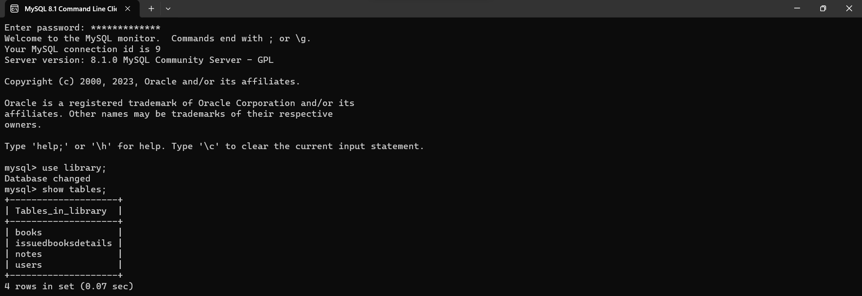

Books Table:

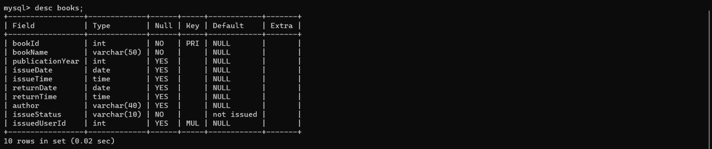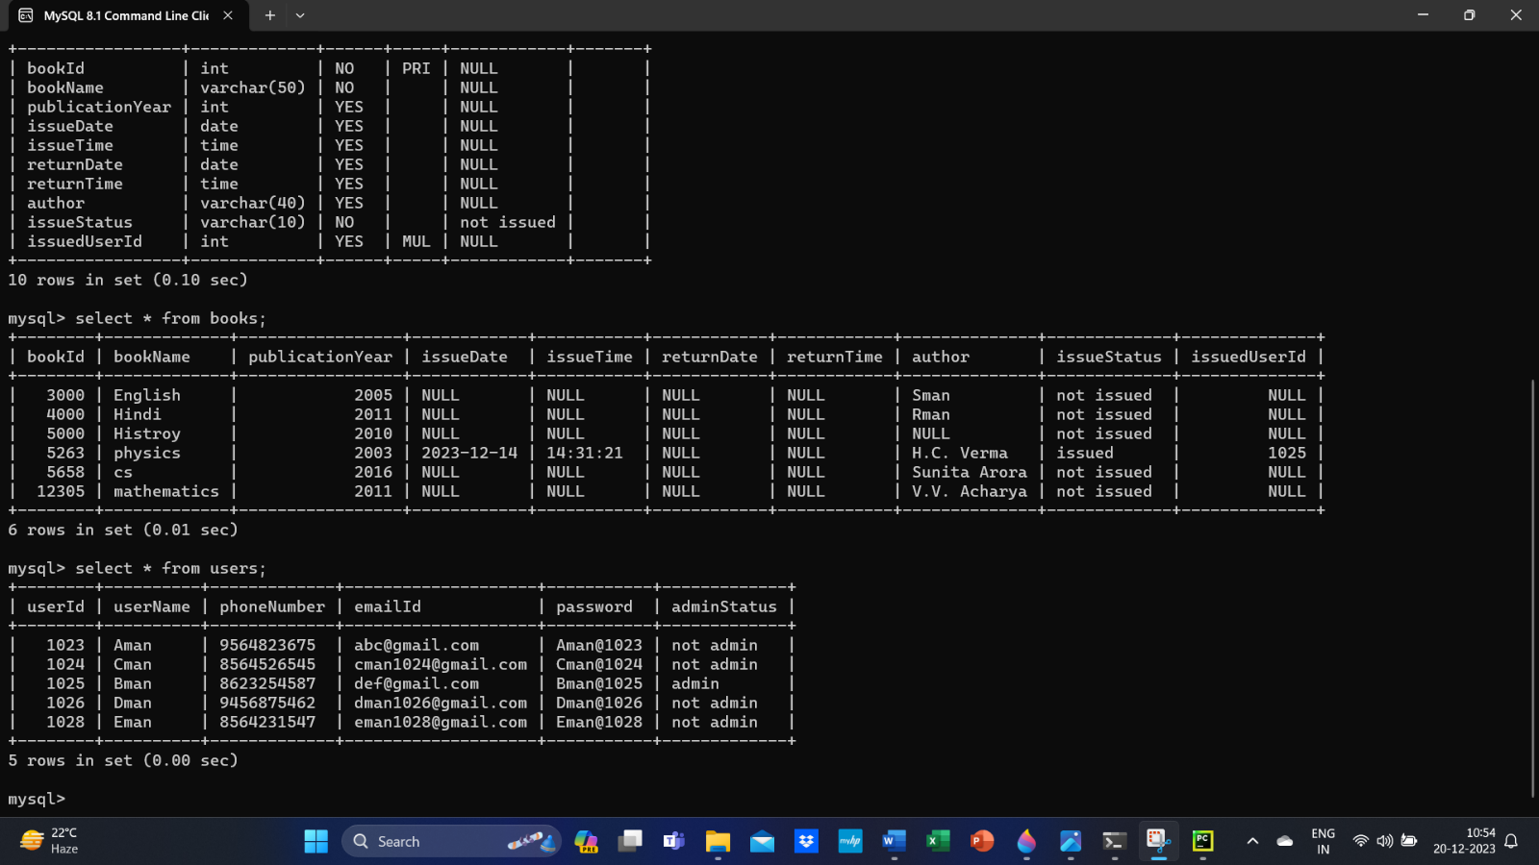

Users Table:

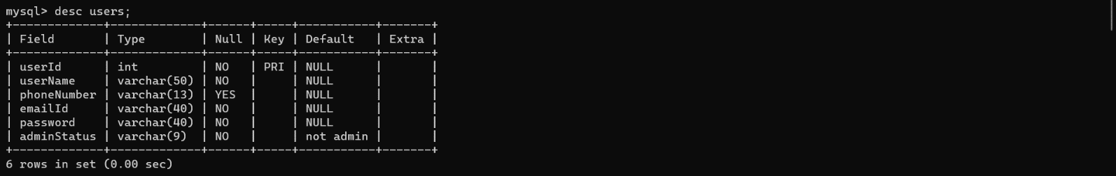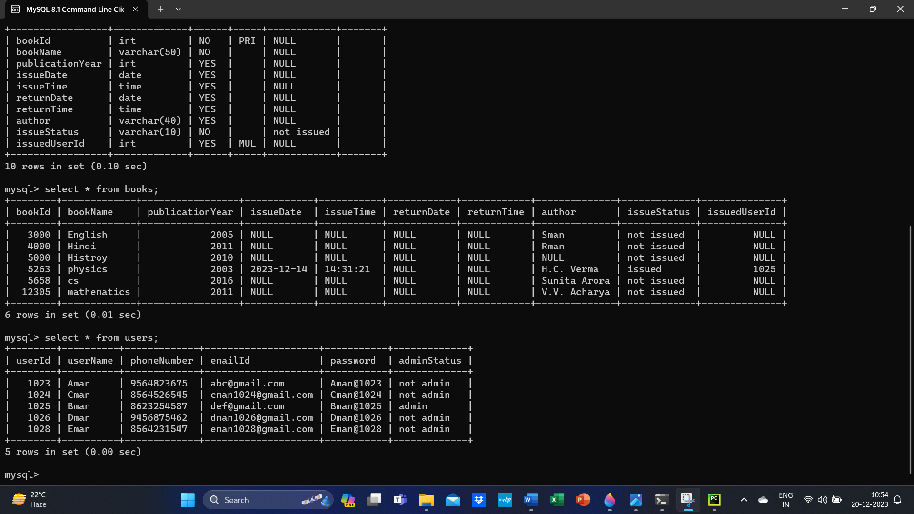

Notes Table:

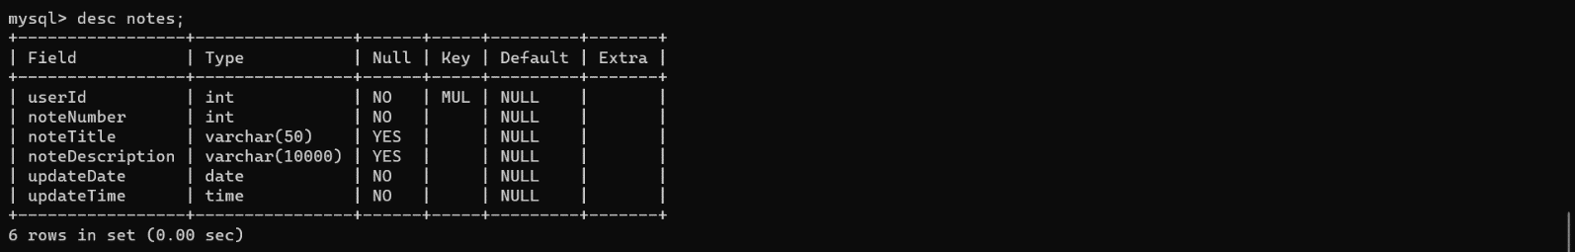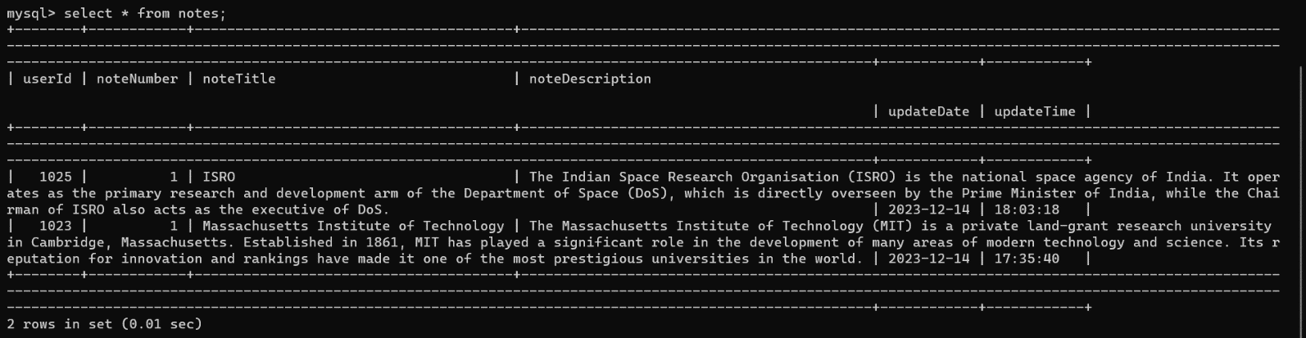

Issued Books Details Table:

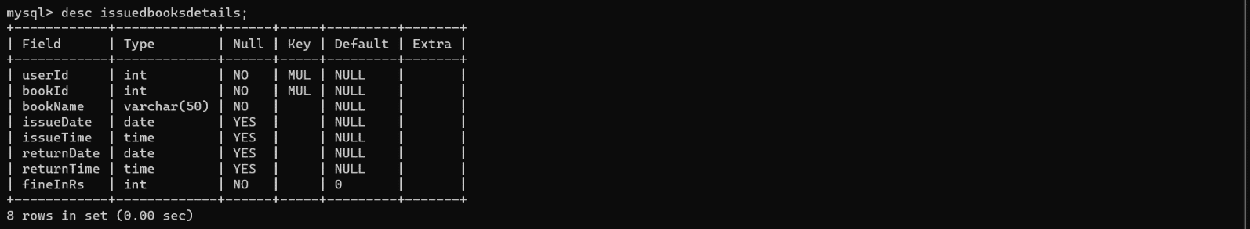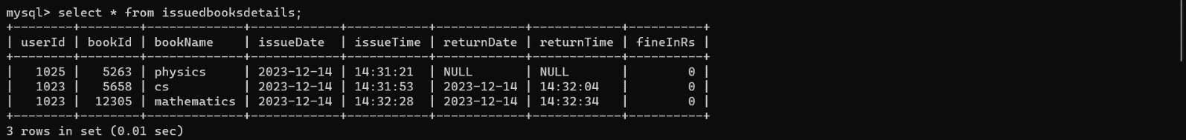

***Outputs***

Starting of the program:

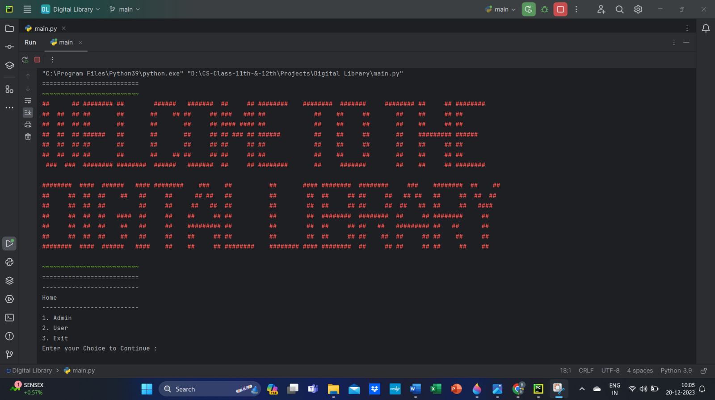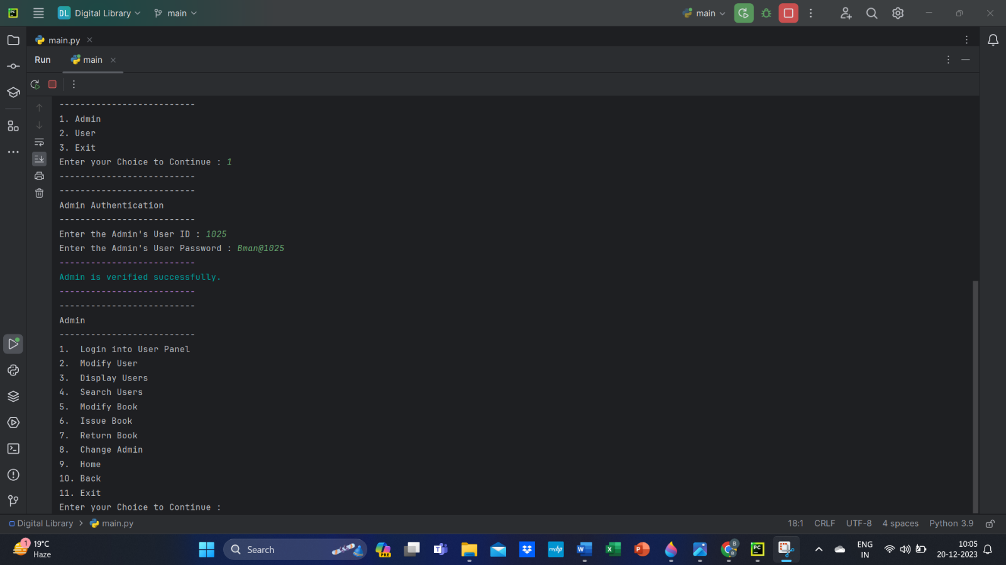

Admin Authentication:

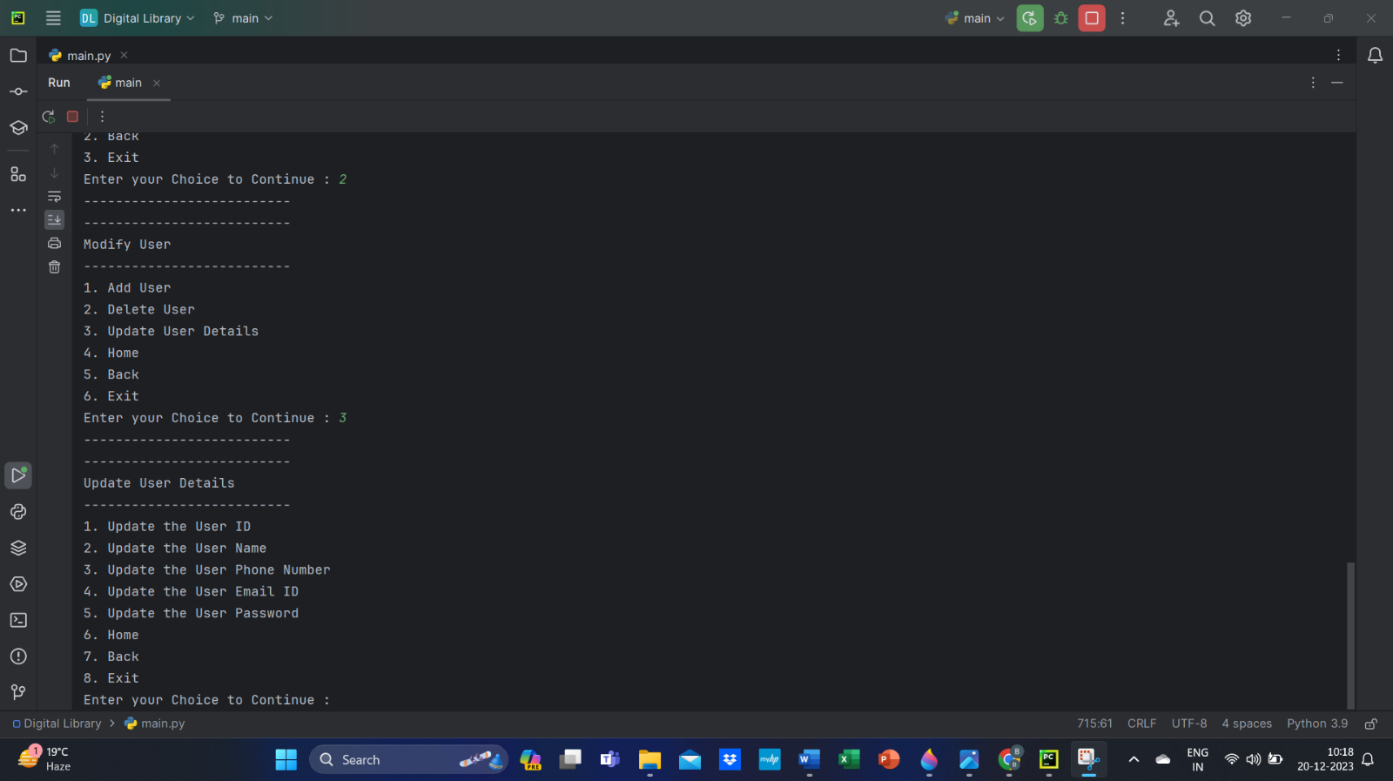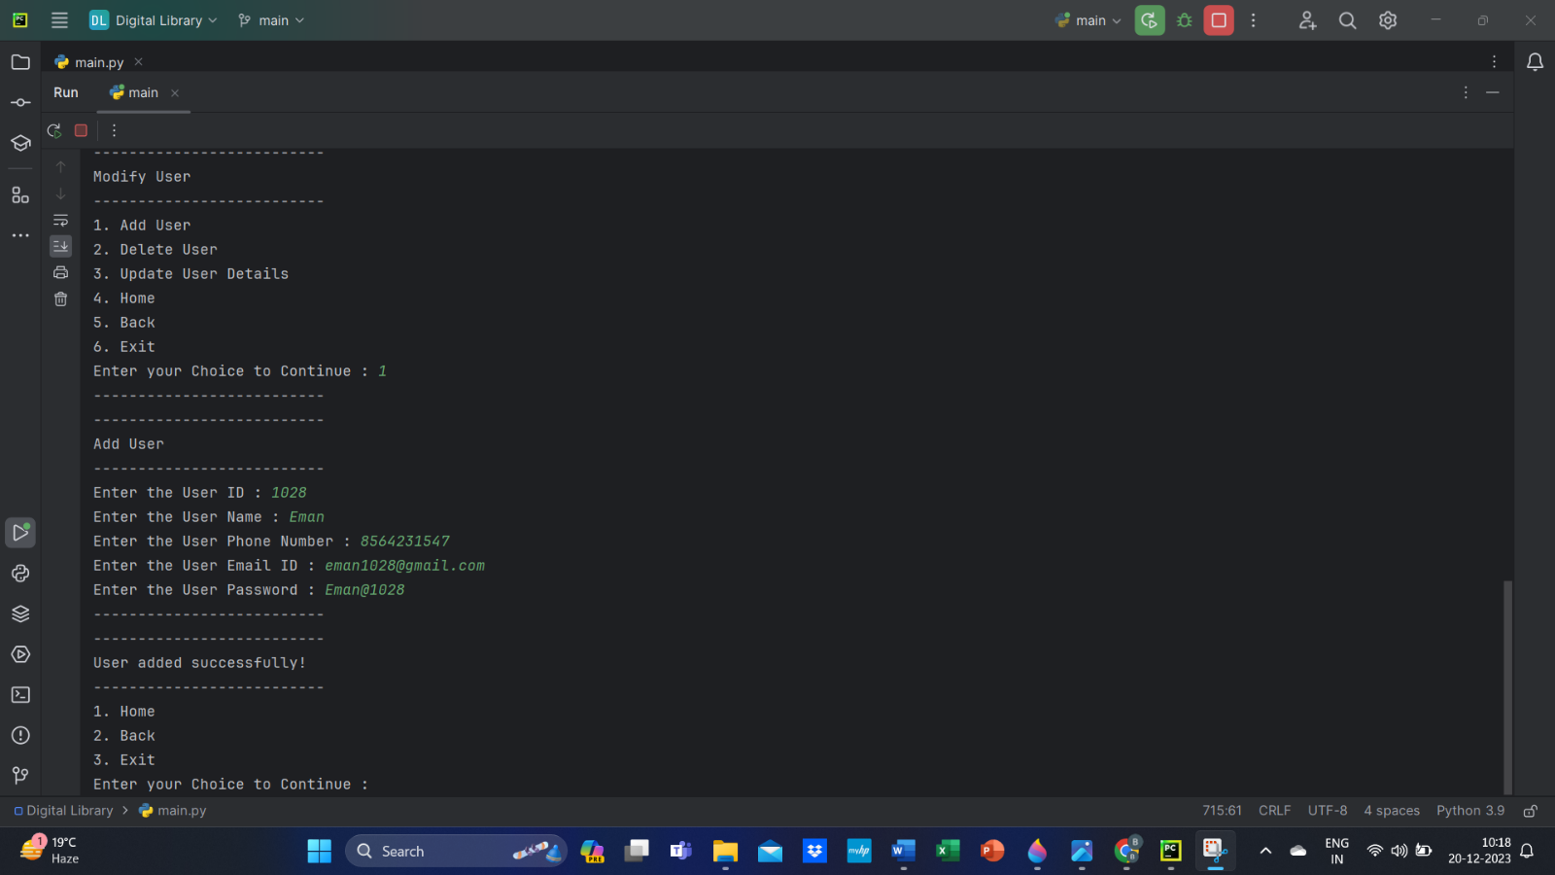

Adding a new user:





Updating user details:

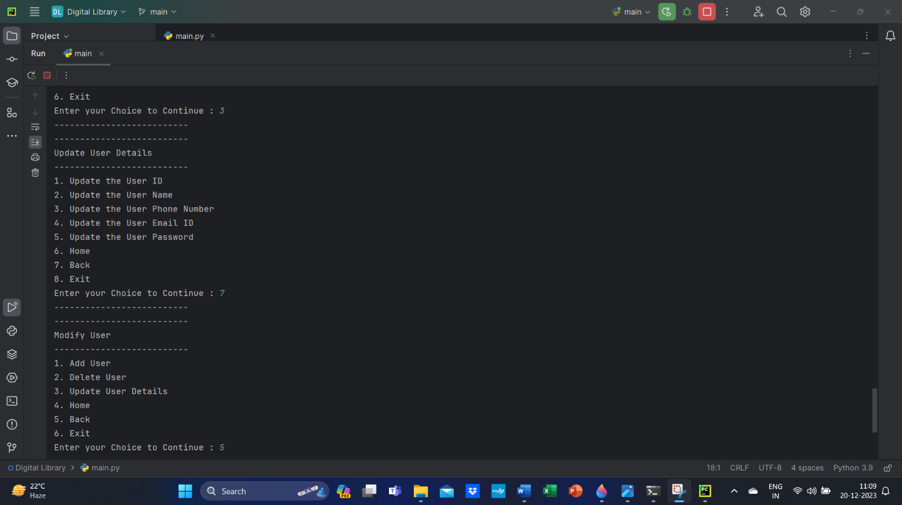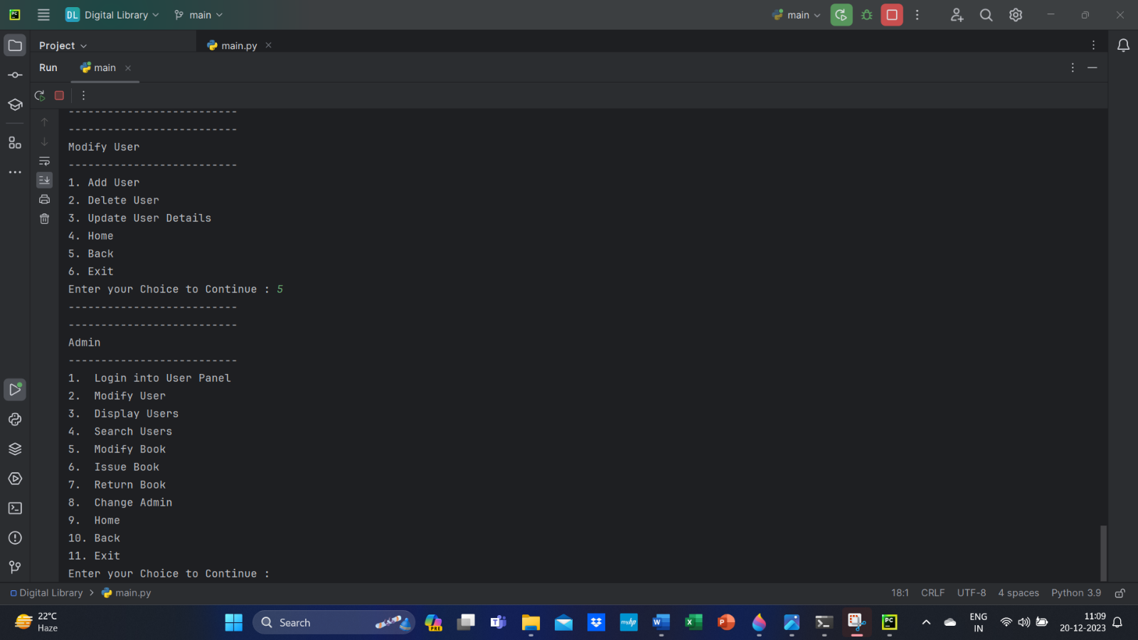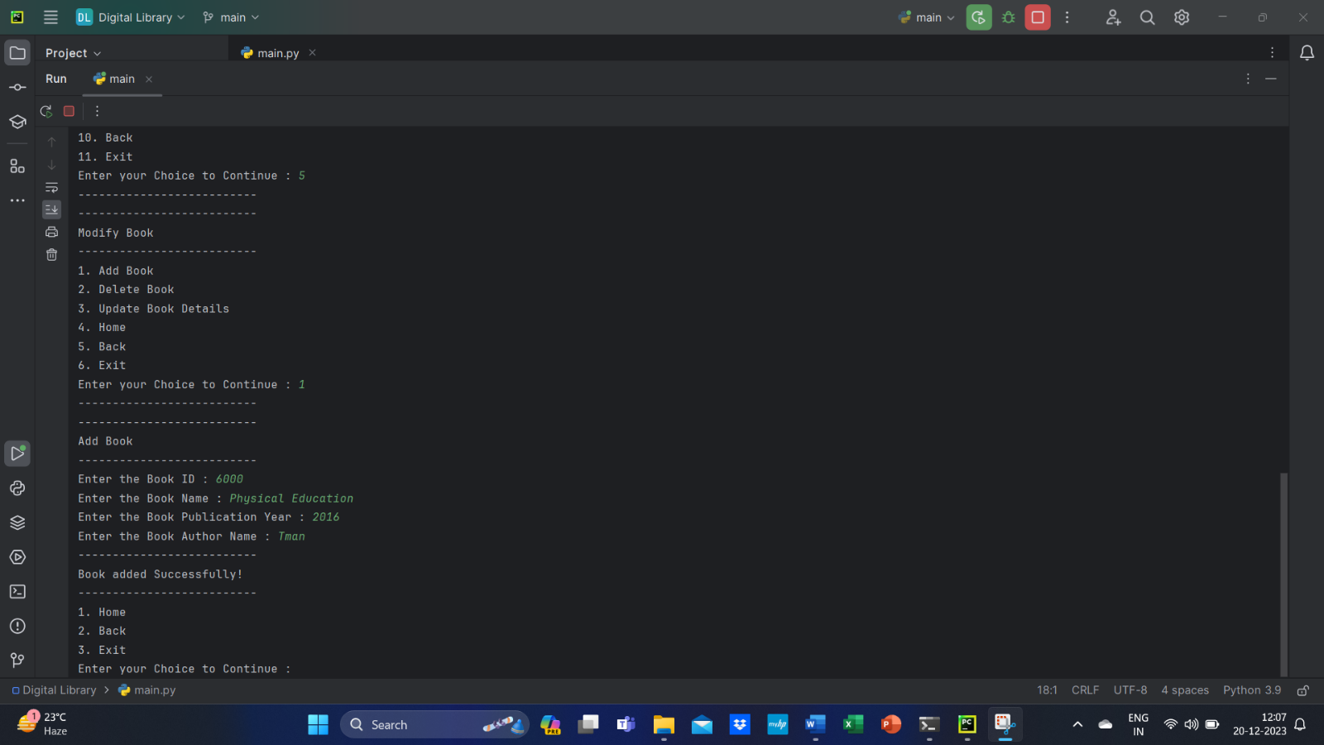

Adding a new book:



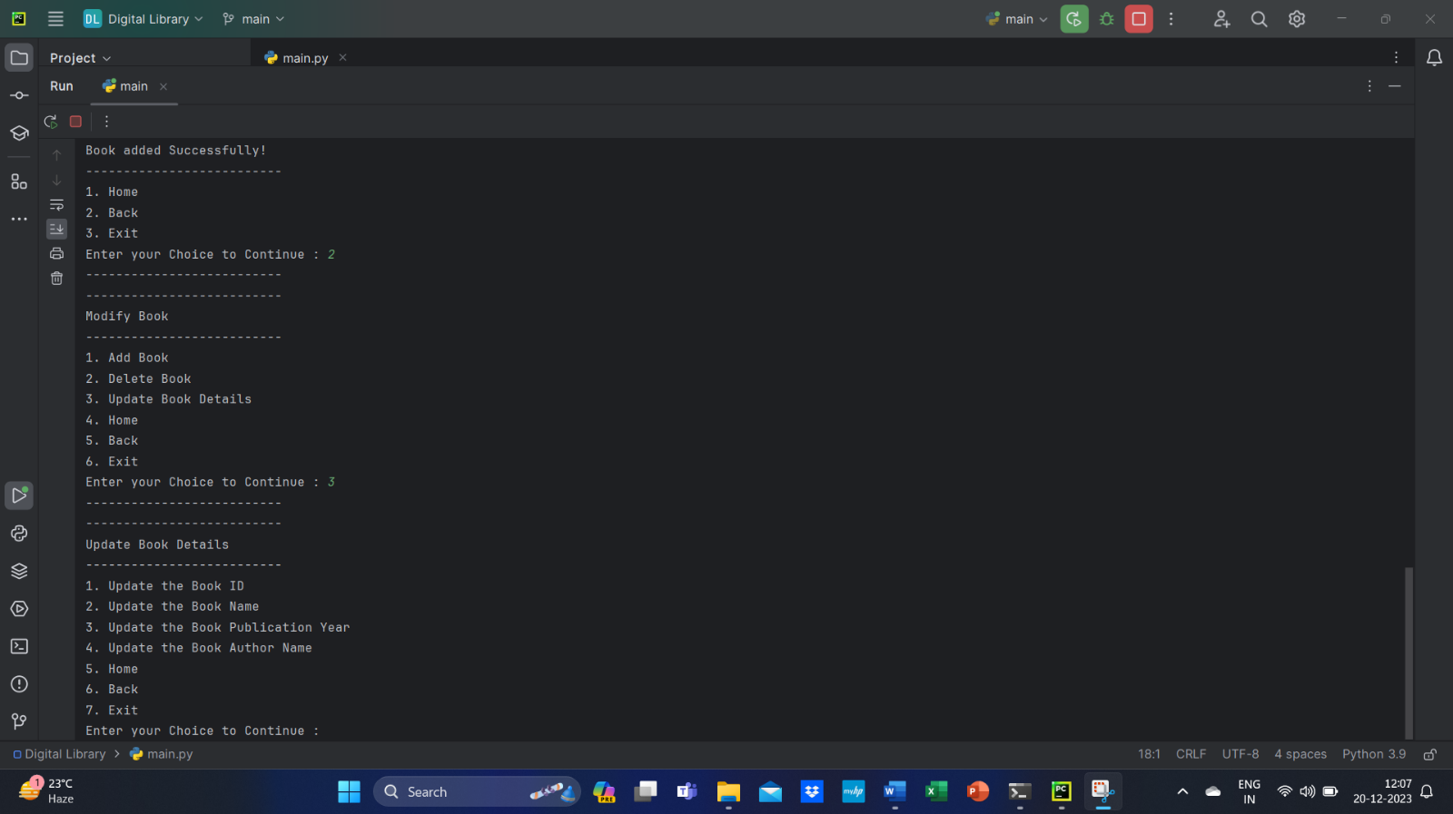

Updating book details:

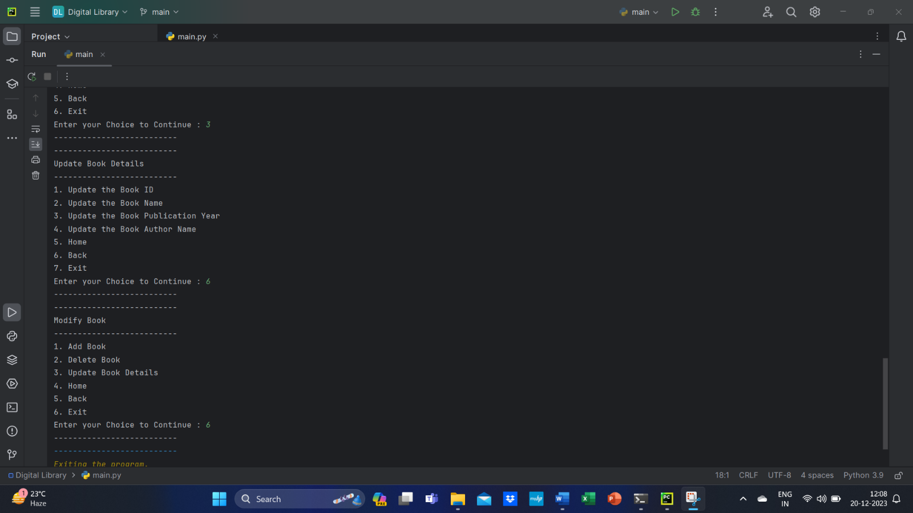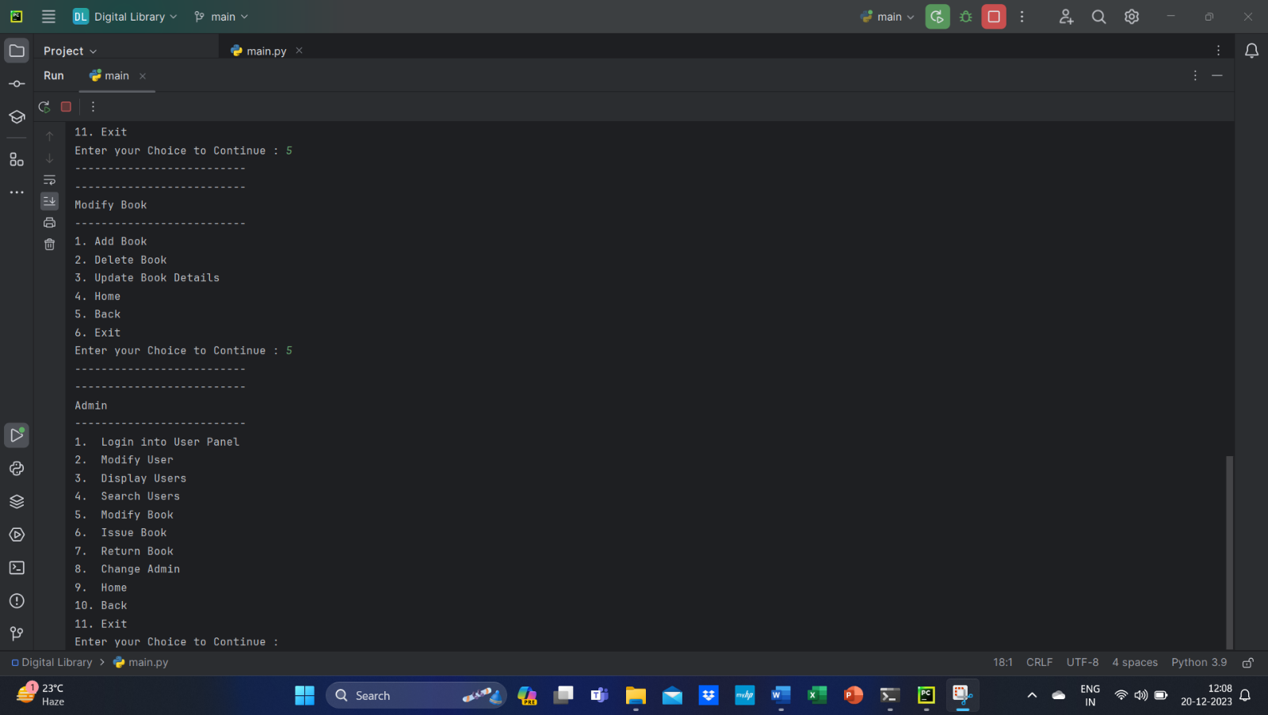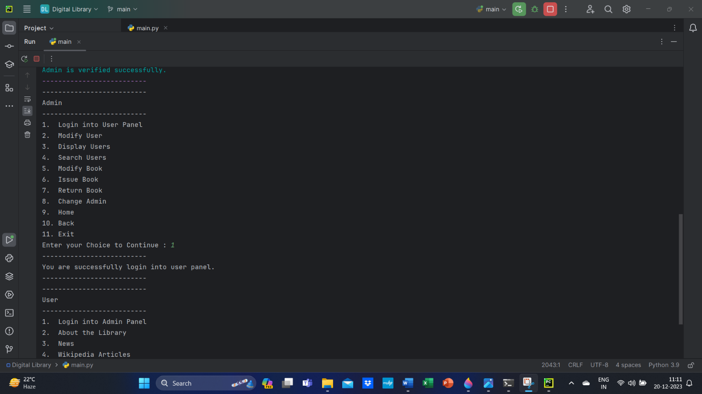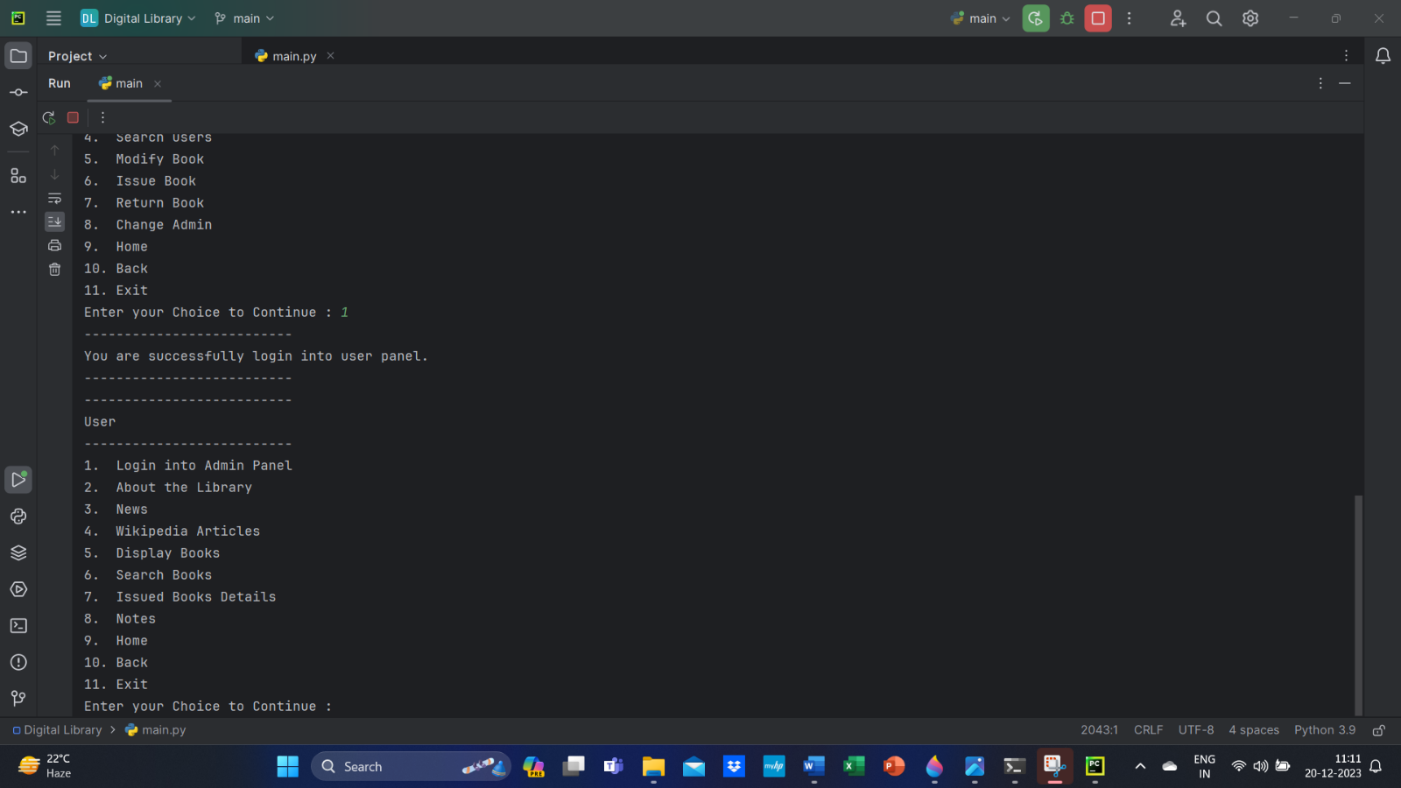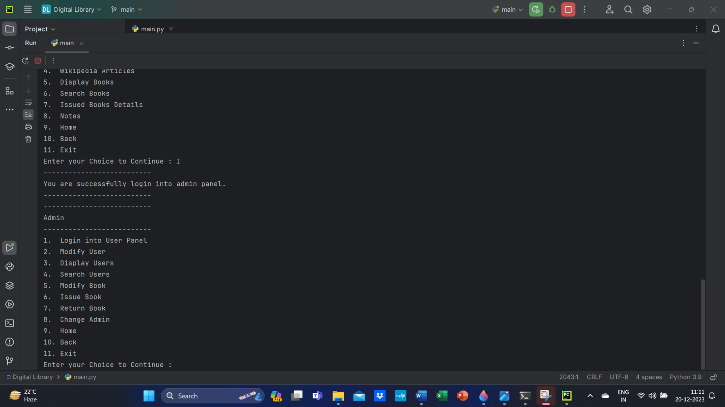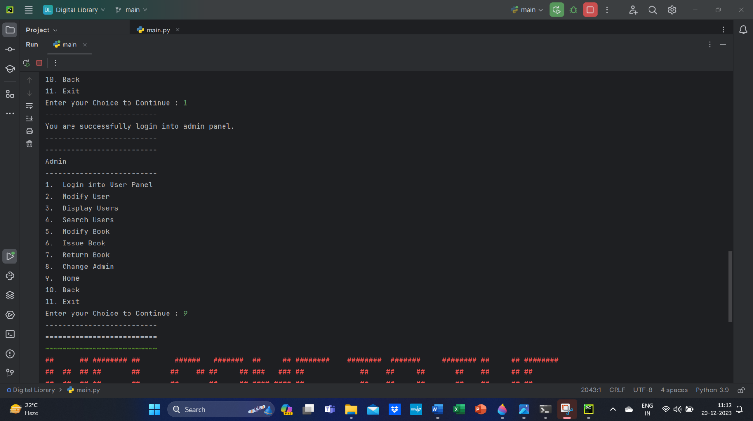

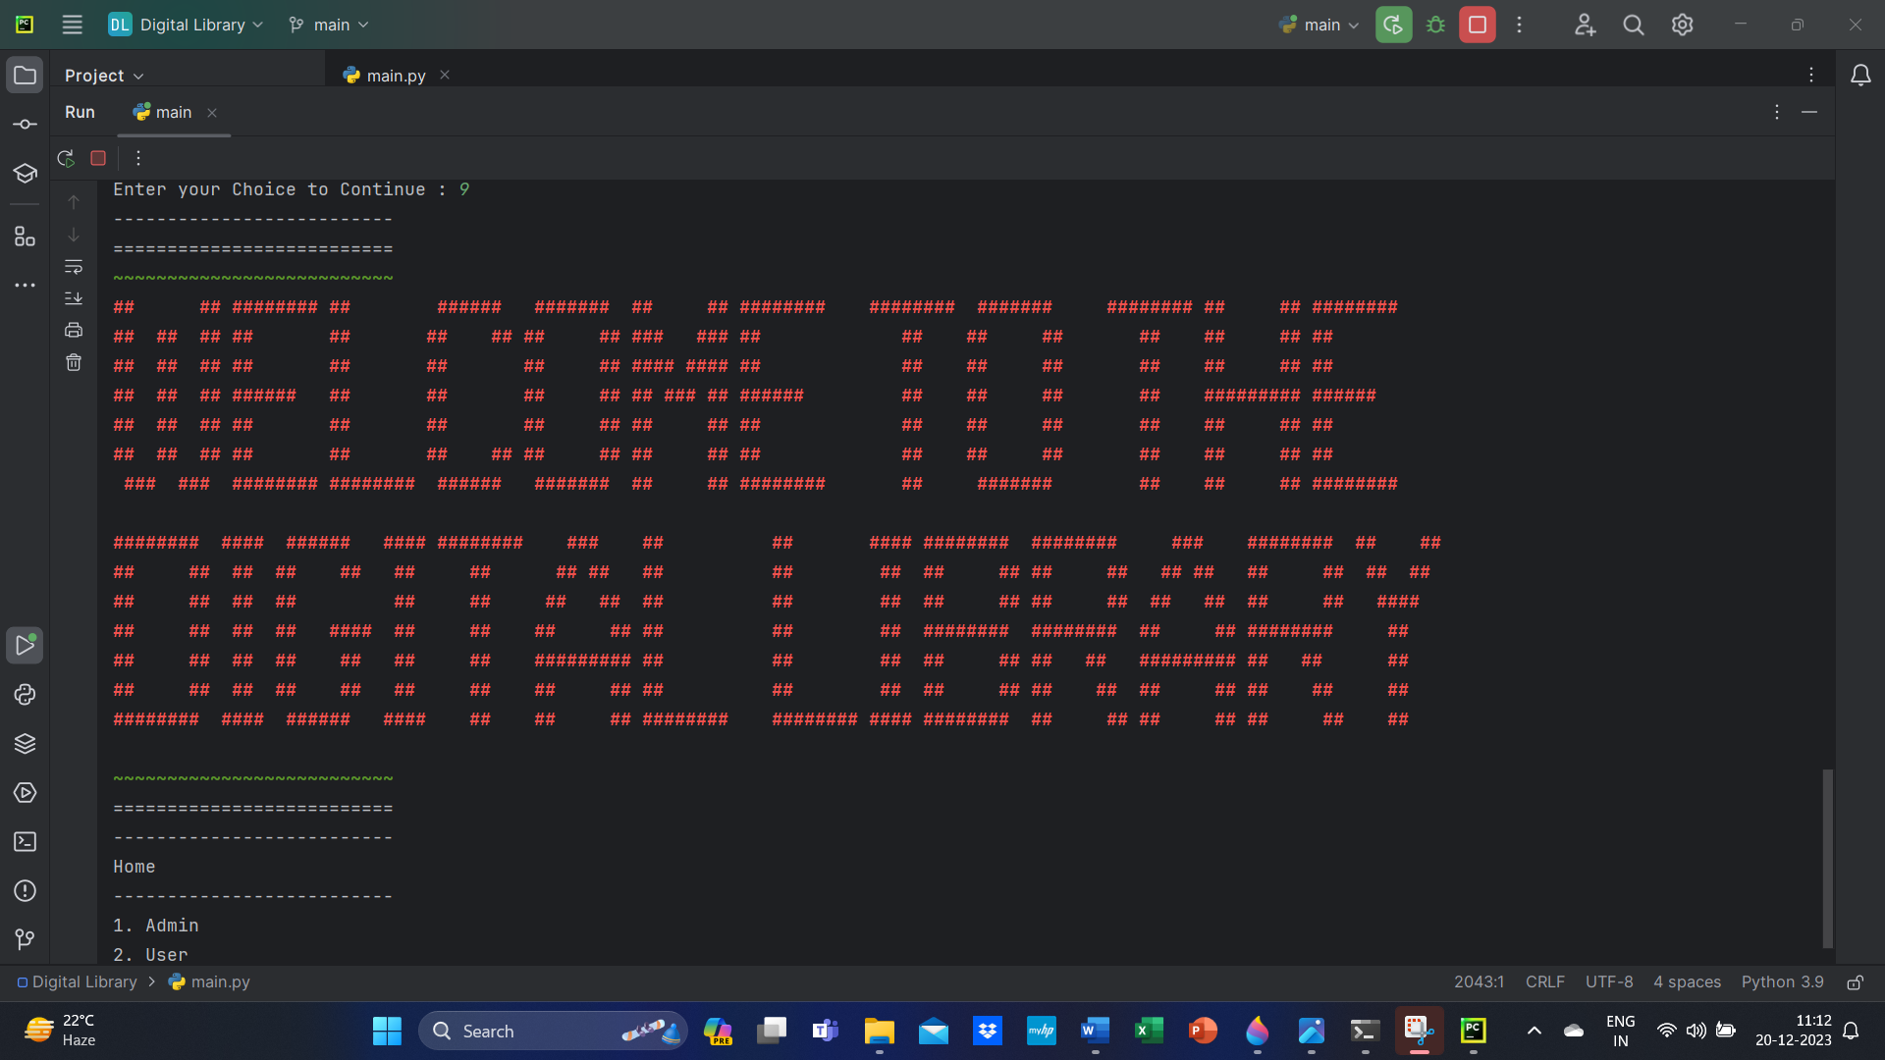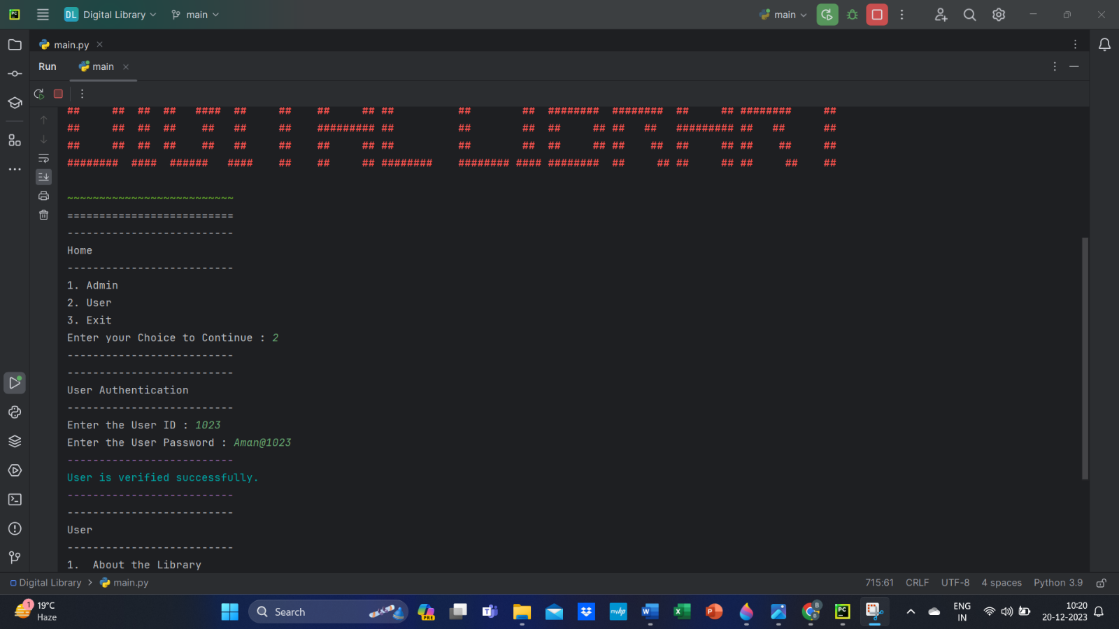

User Authentication:

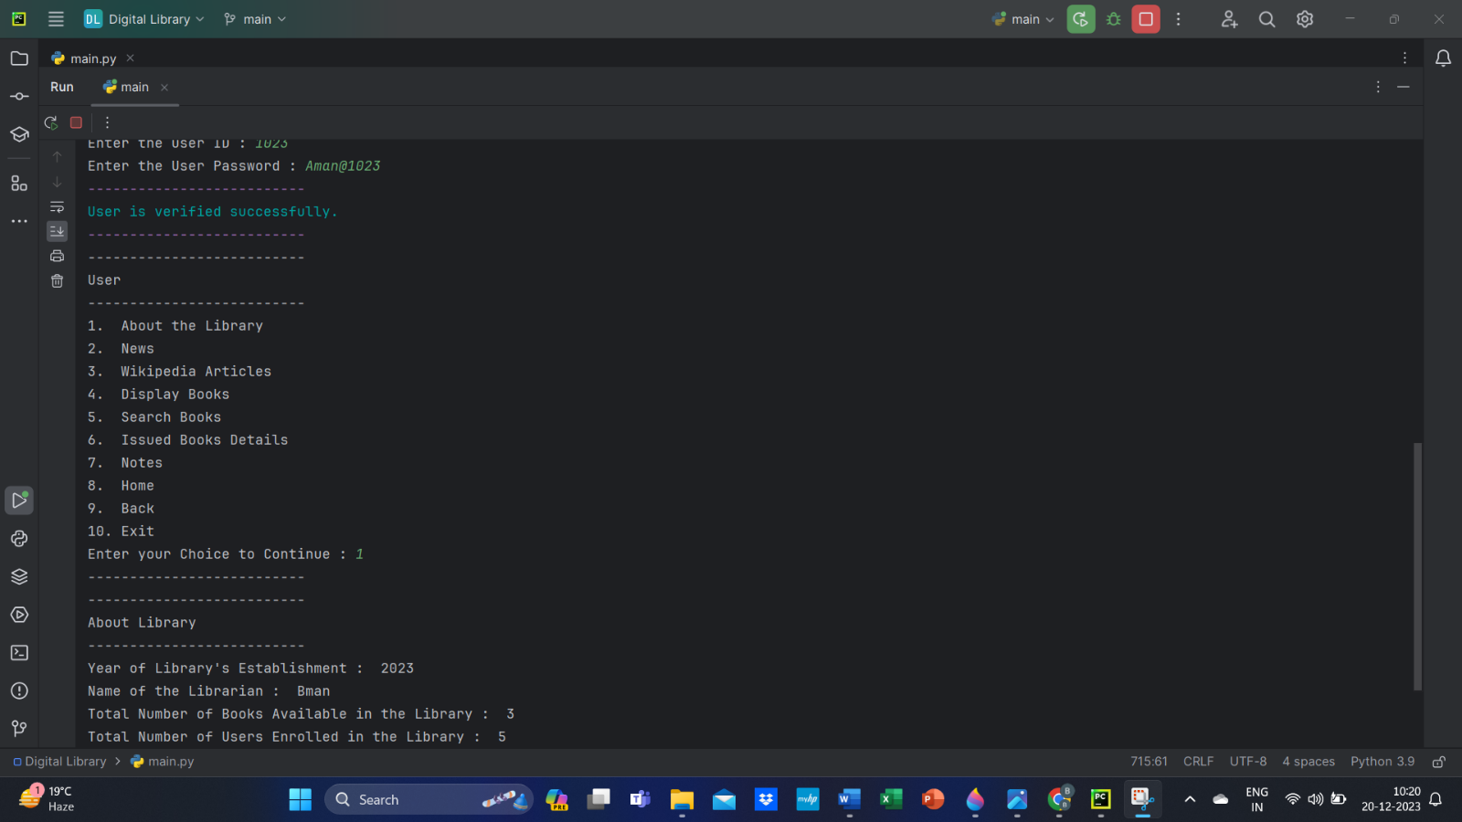

About Library:

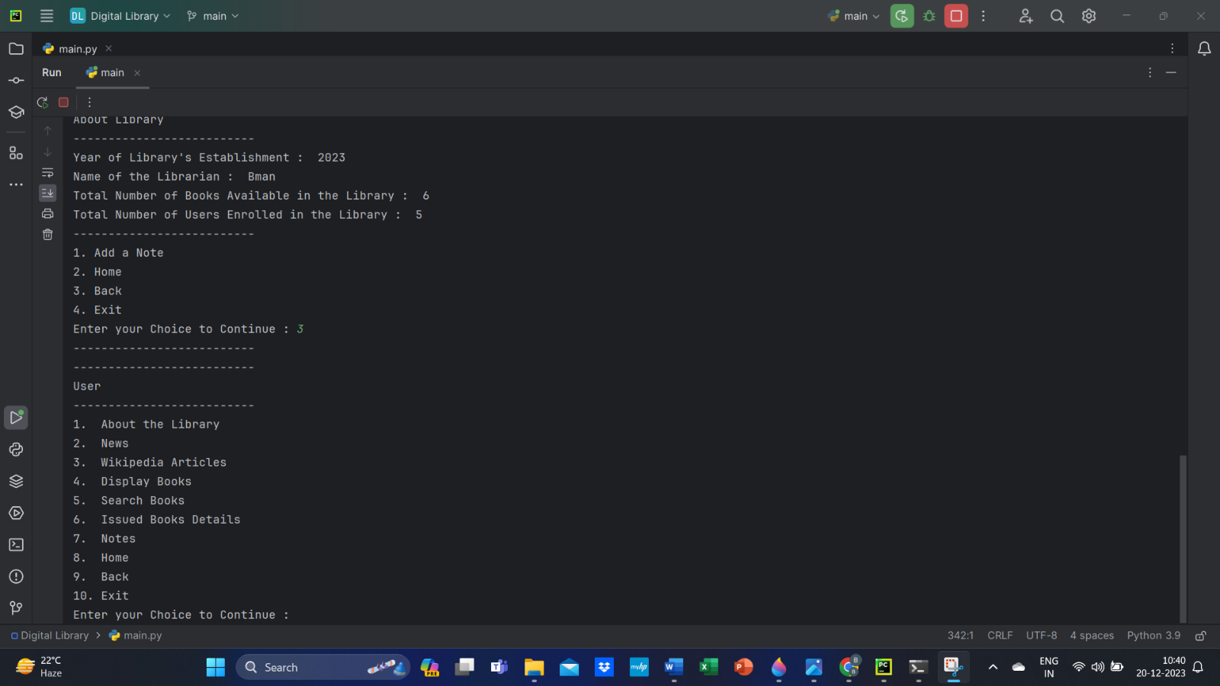

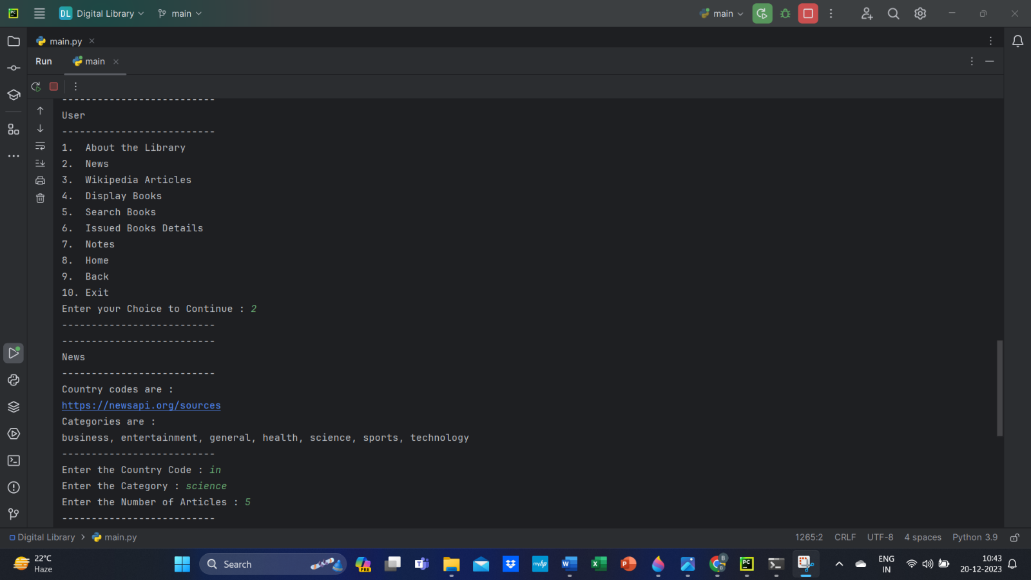

News:

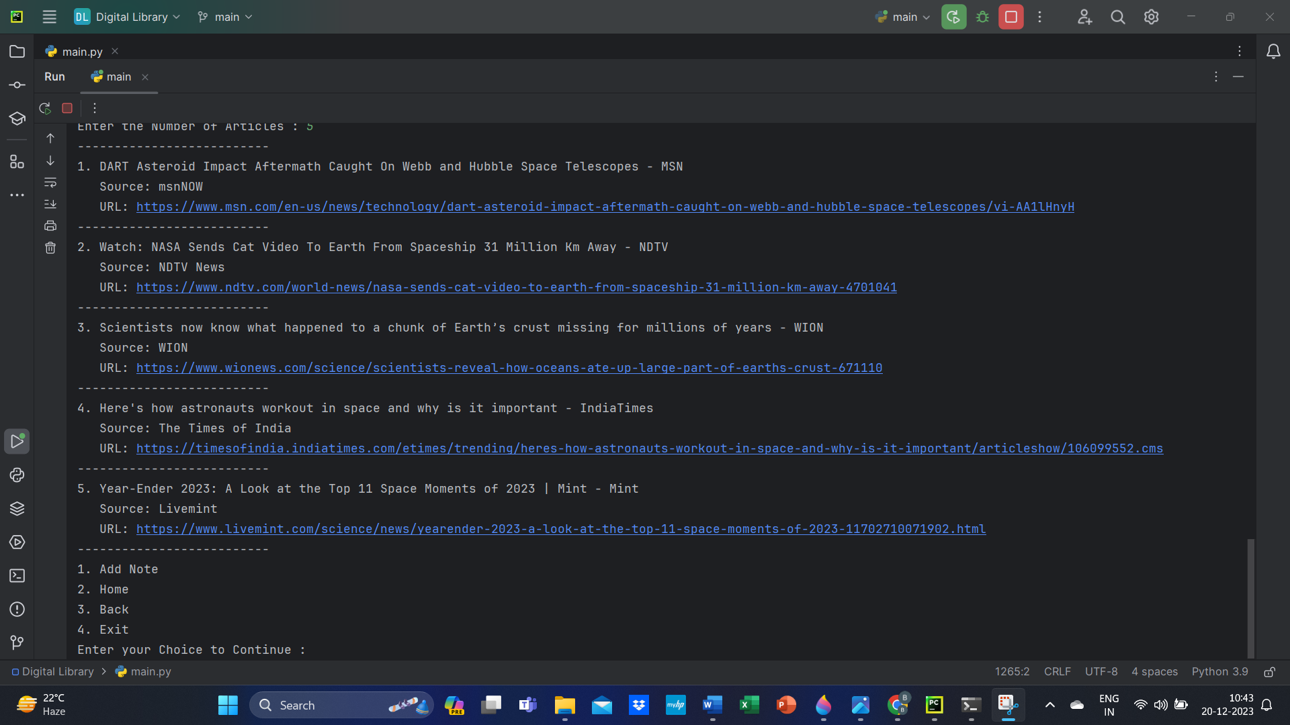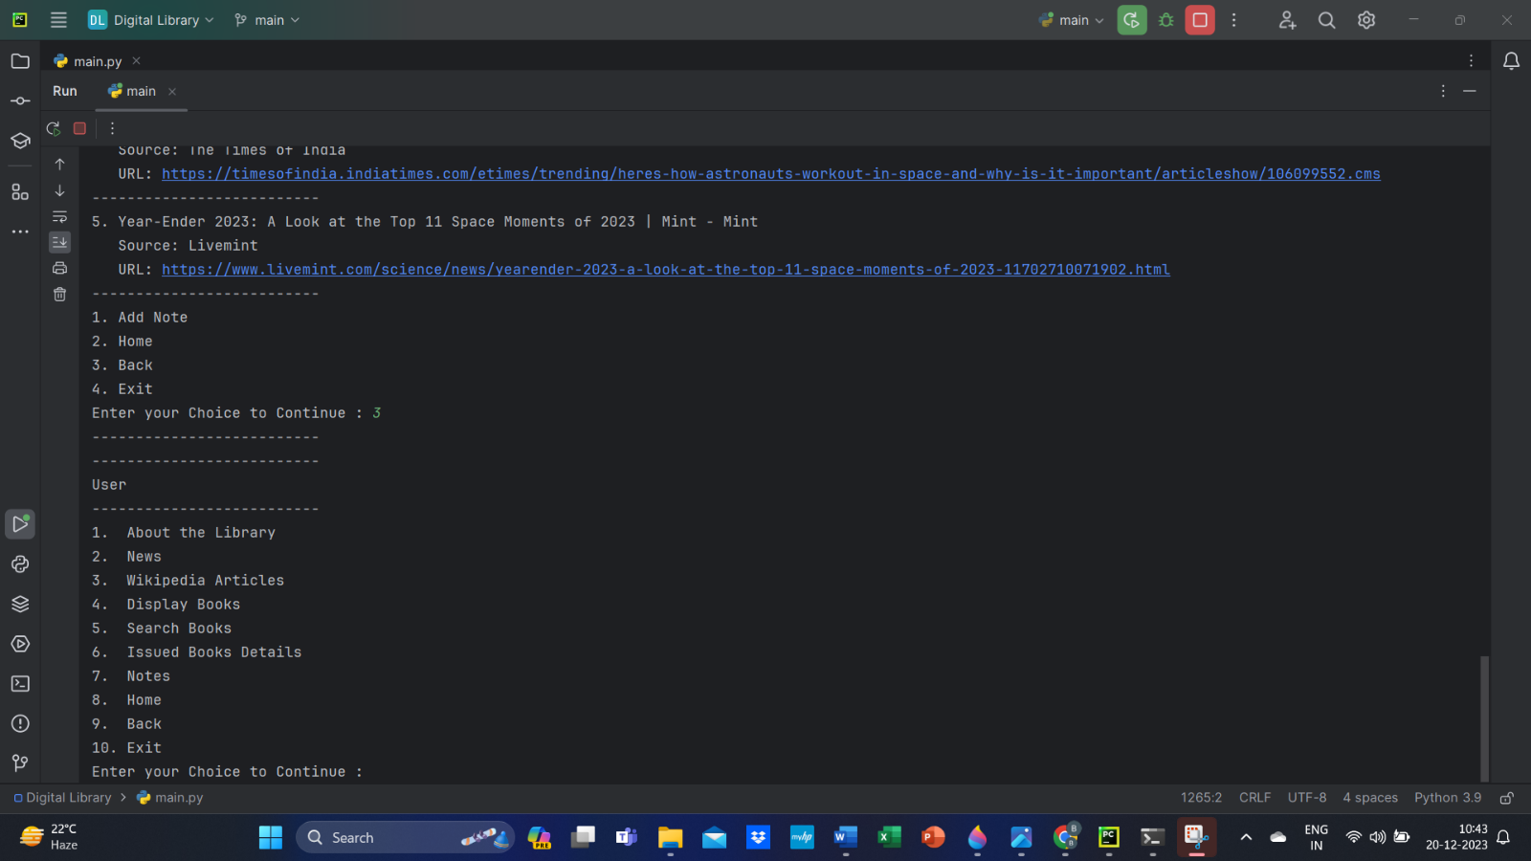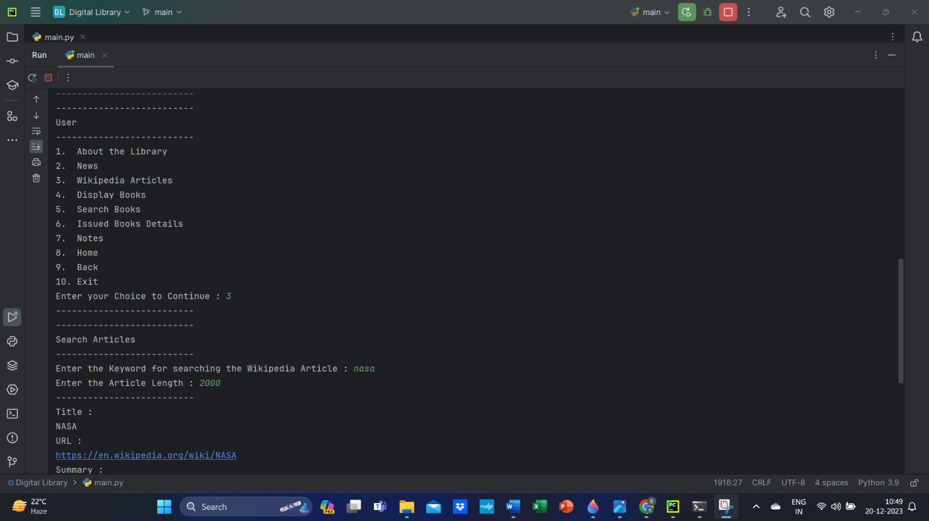

Wikipedia Articles:

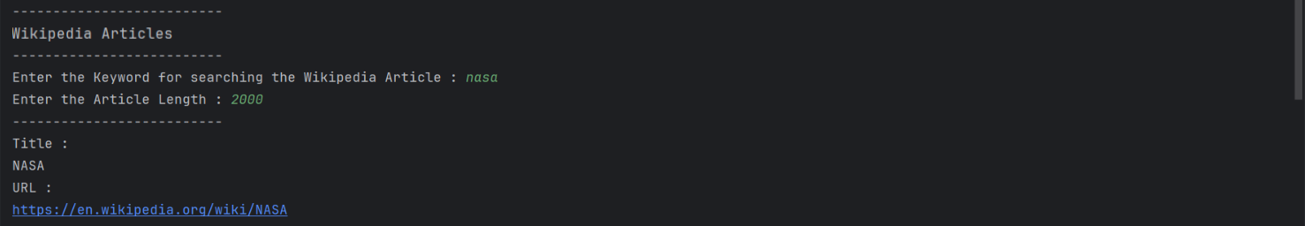

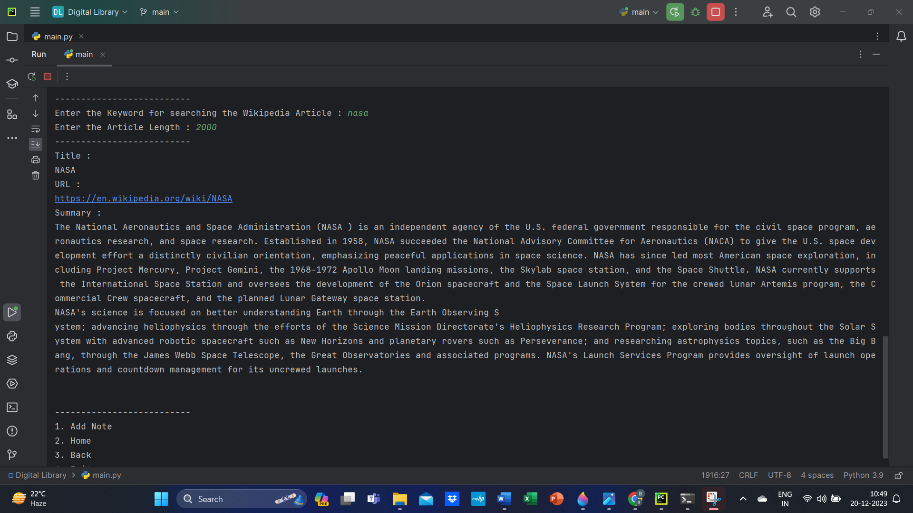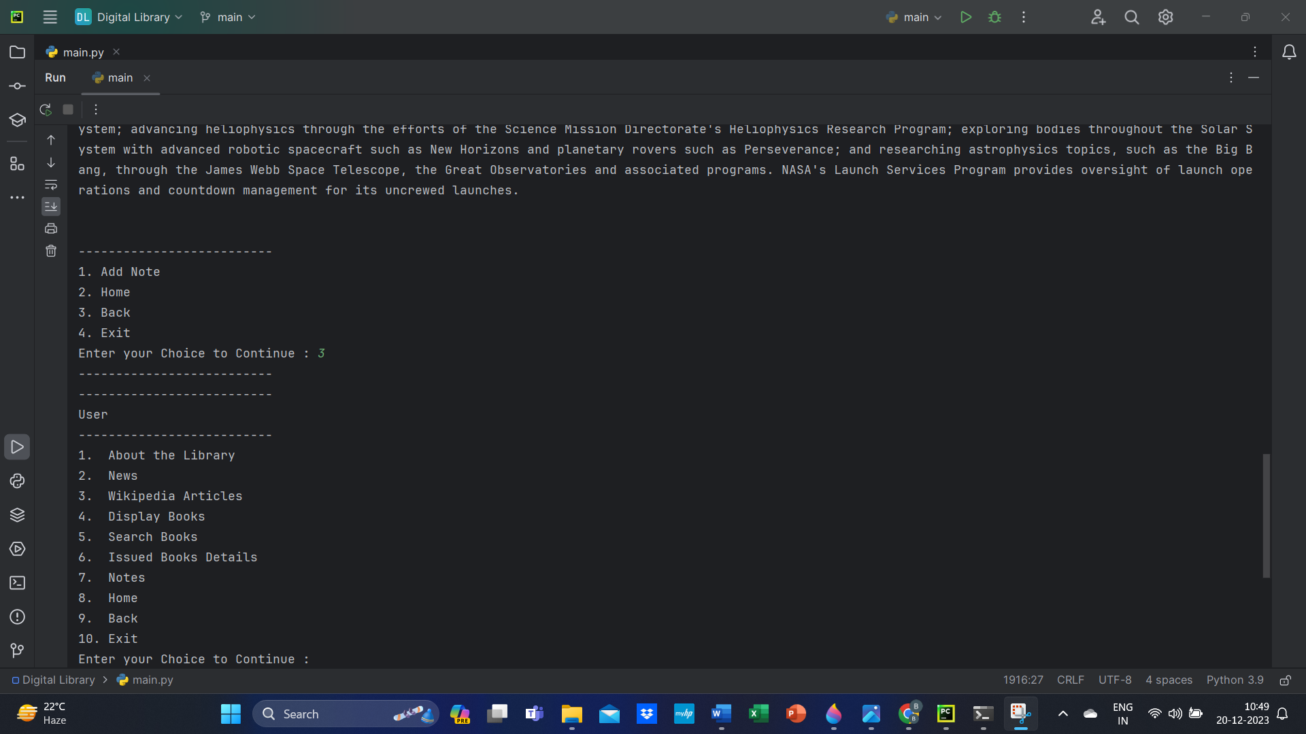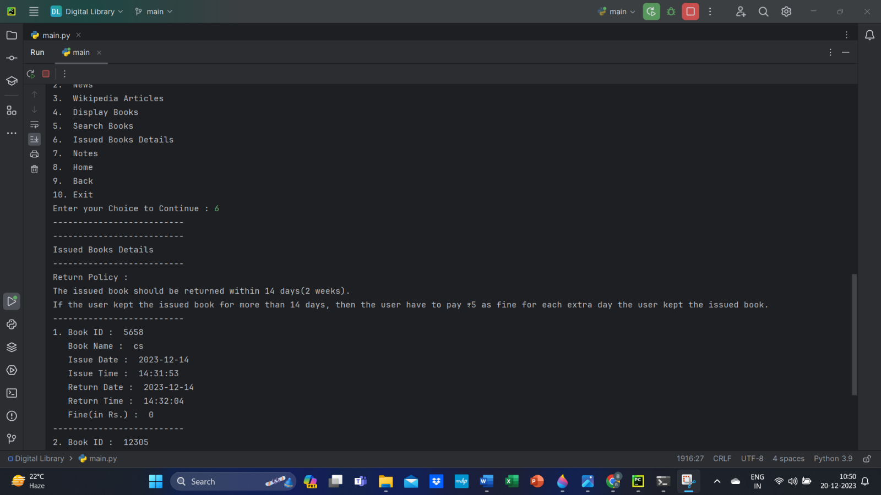

Issued Books Details:

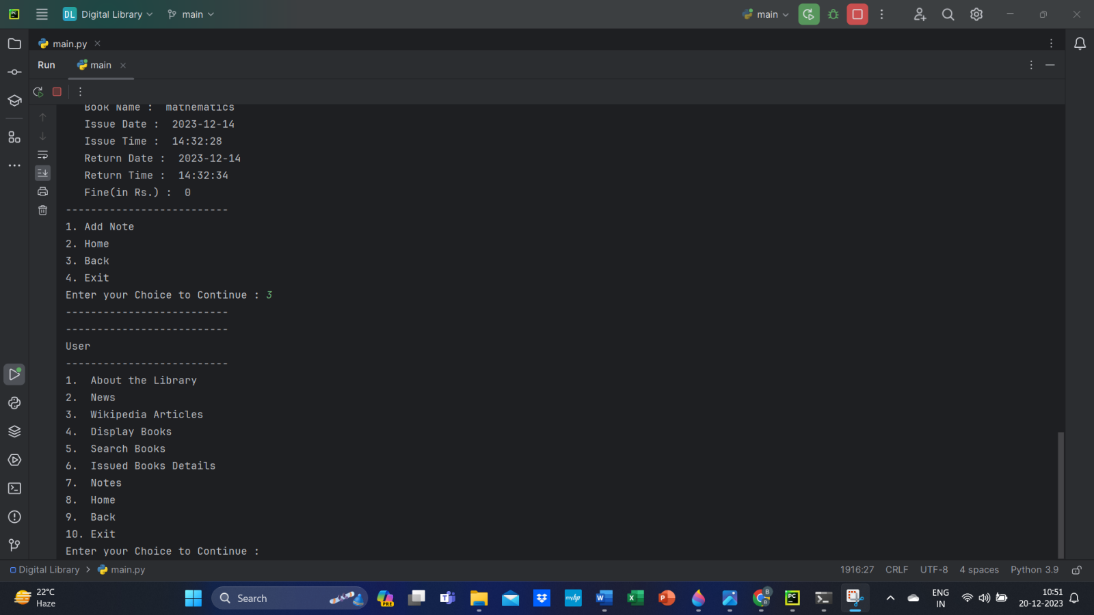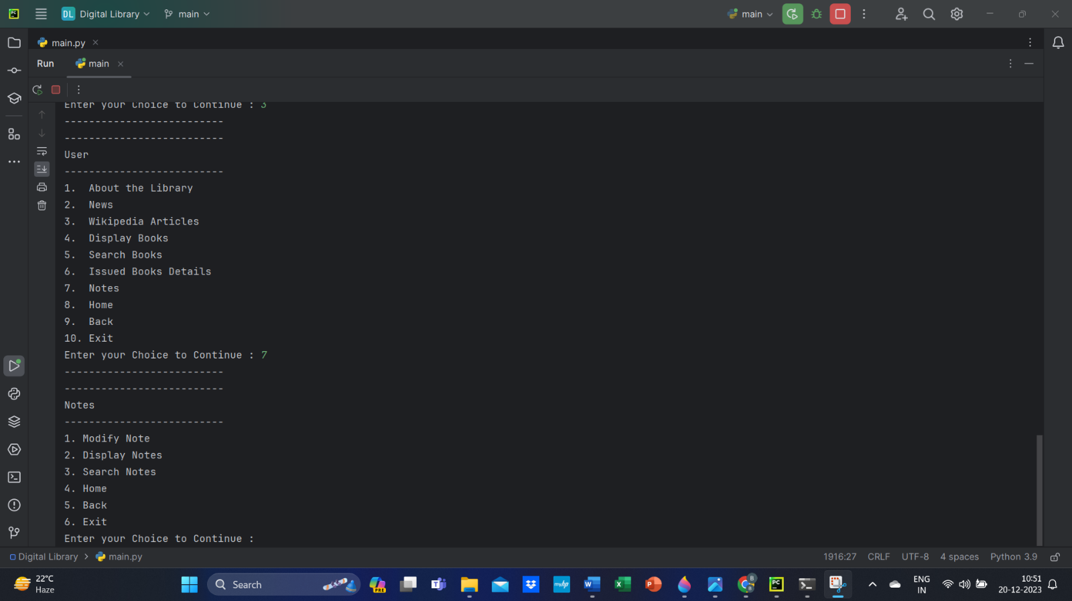

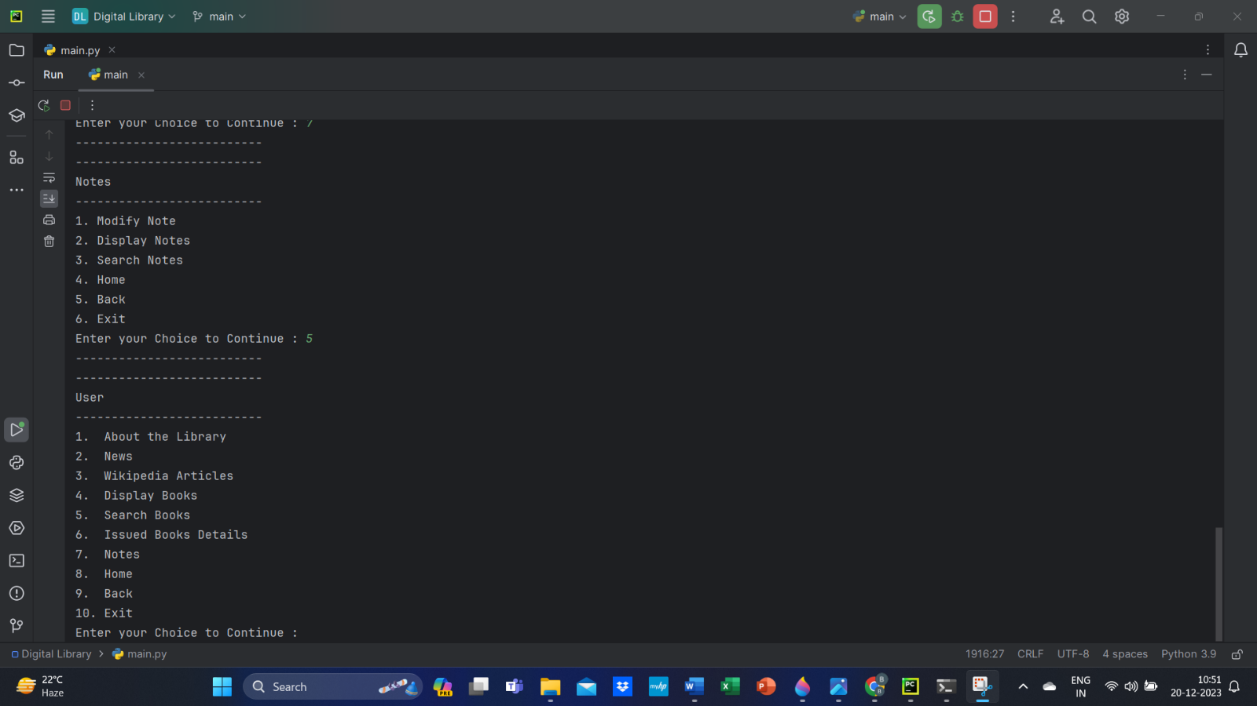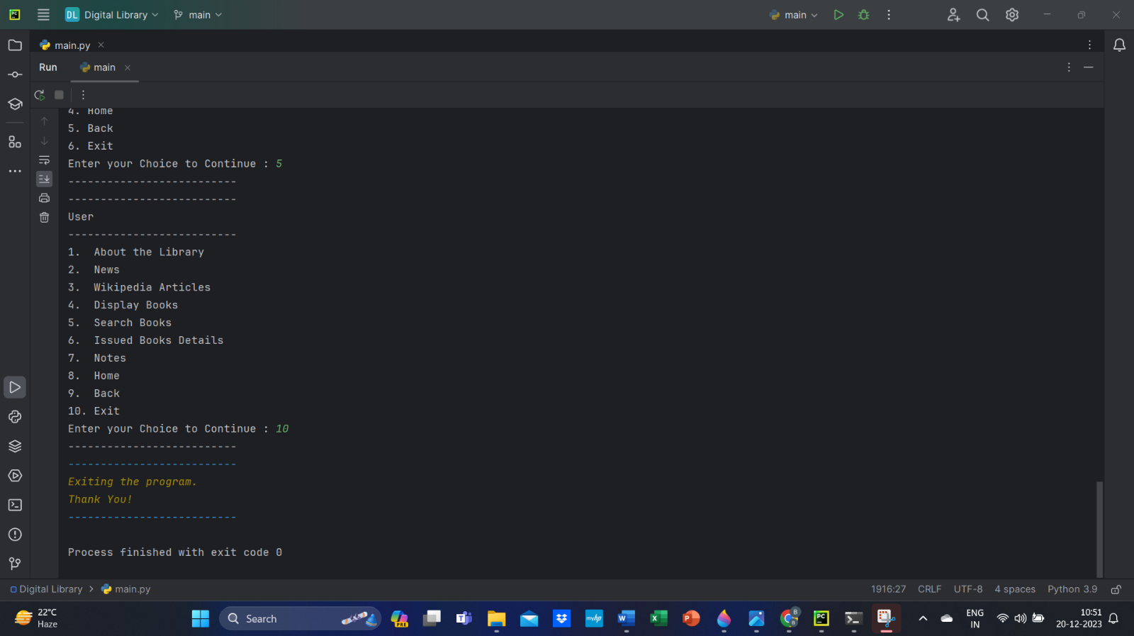

Existing the program:



# REFERENCES

# News API

# <https://newsapi.org/>

# Wikipedia

# <https://www.wikipedia.org/>

# Python

# <https://www.python.org/>

# MySQL

# <https://www.mysql.com/>

# ANSI Escape Codes in Python

# <https://pypi.org/project/ansi/>

# <https://replit.com/talk/learn/ANSI-Escape-Codes-in-Python/22803>

# <https://gist.github.com/rene-d/9e584a7dd2935d0f461904b9f2950007>

# Class 11th & 12th Computer Science Arihant Books